UZIO Scheduling
Getting Started 3
Introduction to Scheduling 3
Enable Scheduling 3
Configuring Scheduling 3
How to Access Scheduling Features? 4
Who Can Manage Scheduling Settings? 4
Who Can Create and Manage Shifts? 5
Who is Visible by Default for Scheduling? 5
Scheduling Grid and Its Key Features 6
Filter 6
Search 7
Different Views of Scheduler grid 7
Week 7
Month 9
Day 9
Show/Hide Cost 11
Show/Hide Hours 12
Wages/Hours Budget 12
Creating Shift 14
Creating Shift for specific employee 14
Creating Shift in bulk 15
Time In/Time Out 16
Project/Job 16
Colour 17
Creating Shifts for Multiple Days 18
Notes 18
Things to Note 18
Creating a Multi Day Shift 19
Schedule Import 19
Publishing Shift 20
Publishing a Specific Shift 20
Publishing Shift in Bulk 20
Overlap Detected 21
Editing a Shift 21
Things to note 22
Deleting Shift 22
Deleting an Specific Shift 22
Deleting Entire Schedule 23
Clear Unpublished Changes 24
Download Schedule 25
Download as PDF 25
Download as XLS 26
Copy Shift 26
Copy to Next 26
Copy from Previous 27
Advanced Option 27
Open Shift 27
What is Open Shift 27
Creating an Open Shift 28
Claiming an Open Shift 28
Viewing or Cancelling the Claimed Shifts 30
Accepting/Rejecting Shift Claim 31
Swap Shift 32
What is swapping a shift 32
How to Swap a Shift 32
Viewing or Cancelling Your Own Swap Shift Requests 35
Accepting/Rejecting the Shift Swap Request 36
Cancelling an Accepted Shift Swap Request 38
Approving/Rejecting Shift Swap Request by Admin 39
Offer Shift 42
What is Offering a Shift 42
How to Offer a Shift 42
Viewing or Cancelling Your Own Offer Shift Requests 44
Accepting/Rejecting the Shift Offer Request 45
Cancelling the Accepted Shift Offer Request 47
Approving/Rejecting Shift Offer Request by Admin 48
Schedule Notifications 49
Employee Notifications 51
Reminder to start shift on time 51
Sample PUSH Notification 51
Reminder to end shift on time 51
Sample PUSH Notification 51
Notification of Shift Publish 52
Alert to employee on early shift start 52
Alert to employee on late shift start 53
Alert to employee on early shift end 54
Alert to employee on late shift end 54
Alert to employee on No Show of Shift 55
Manager Notifications 56
Alert to manager if do not start shift by time 56
Alert to manager if do not end shift by time 57
Alert to manager on early shift start 57
Alert to manager on late shift start 58
Alert to manager on early shift end 59
Alert to manager on late shift endt 60
Alert to manager on NO Show of Shift 60
Schedule Settings 61
Prevent Early Clock In 62
Mark Late Clock In 62
Default Shift Timings 63
Employee Experience of Schedule on Web 63
Employee Experience of Schedule on Mobile 63

Getting Started

Introduction to Scheduling
The objective of this article is to empower users with the knowledge and tools to effectively use Uzio's Shift and Scheduling feature. This tool streamlines workforce management, ensuring efficient and fair work hour distribution while enhancing employee satisfaction. The article provides clear instructions for setting up and managing schedules, helping administrators maximize productivity and reduce administrative tasks.

Enable Scheduling
Before you start using the Shift and Scheduling feature on your account, please ensure that you have subscribed to the scheduling feature in conjunction with time tracking. If you are already subscribed, then you are all set to use this functionality. If not, please drop a note at support@uzio.com. Our team will reach out to you and share the plan details, and provide a live demo if required, before you subscribe to the feature.

Configuring Scheduling
Unlike time tracking, there is no initial setup required for using scheduling after getting enabled by the UZIO team. If you need you can configure some optional settings of scheduling by opening Time Tracking Settings from the left navigation and going to Schedule.

How to Access Scheduling Features?
Log in to the Uzio employer portal. In the left menu under the Time Tracking section, you will see "Schedule." Click on that to access the scheduling feature. From here, you can effortlessly create and manage your employees' schedules.
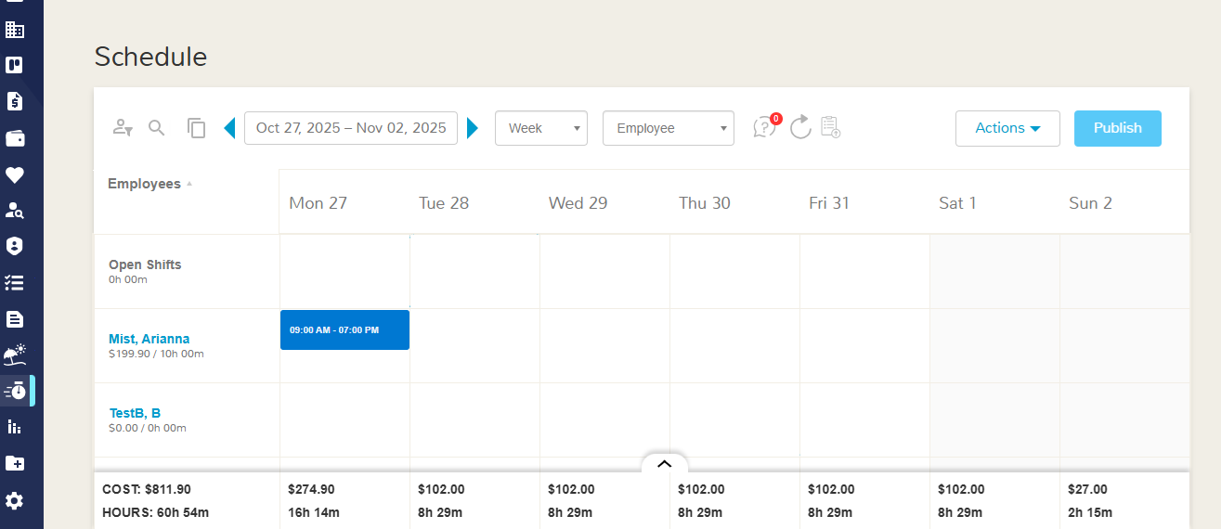

Who Can Manage Scheduling Settings?
Employer administrators or any user in the company who has been granted edit access to the company-level permissions for the "Schedule and Time Tracking" can manage the Schedule settings and notifications for the company. To grant this permission follow the steps
- Login as Employer Admin.
- Open Manage Users from the left navigation menu
- Locate or add the role and go to Company Access and find the setting Schedule and Time Tracking Settings.
- Set the permissions as required
  - No Access- No access to manage schedule and time tracking settings.
  - View Access- View access to schedule and time tracking settings. Means cannot add employee, manage Overtime or break rules, manage geofence, schedule settings or time tracking settings.
  - Full Access- Full access to schedule and time tracking settings. Means the user can add employees for time tracking and scheduling, manage Overtime or break rules, manage geofence, schedule settings or time tracking settings.

Who Can Create and Manage Shifts?
Employer administrators or any user in the company who has been granted edit access to the employee-level permissions for the "Employee Schedule" can manage shifts of the accessible employees.
No Access- The user cannot view the employee schedule.
View Access- The user can view the employee schedule but cannot add, edit, delete, copy, import or approve shifts. It means the view only actions are available to the user but the user cannot perform any transaction.
Full Access- The user can view as well as add, edit, delete, copy, import or approve shifts.

Who is Visible by Default for Scheduling?
All employees, regardless of their pay type (hourly or salaried), who are selected for time tracking are by default visible in the scheduling module. You can create and manage their shifts. If you want to add or remove any employee from scheduling, follow the steps
- Login as Employer User
- Open "Time Settings" from the left navigation
- Go to Employees Tab
- Select “Select Employees” to add the employee for Time Tracking ans Scheduling
- Select “Remove Employee” action to remove the employee from time tracking and scheduling.

Scheduling Grid and Its Key Features
The Scheduling grid is a tabular layout where employer users can easily view employee shifts either by their name or work location for the selected day, week, or month. Within this grid, employer users can take several actions on individual shifts as well as on groups of shifts, such as the entire schedule.

Filter
Use the grid’s filter panel to refine which shifts you see. You can filter by
- Work Location
- Department
- Job Title
- Pay Group
- Pay Type
- Employment Type
You may combine multiple filters at once to narrow results to a specific segment (e.g., “Hourly staff at Station 1 work location”). Filters remain in effect until you clear them, and the grid updates in real time.

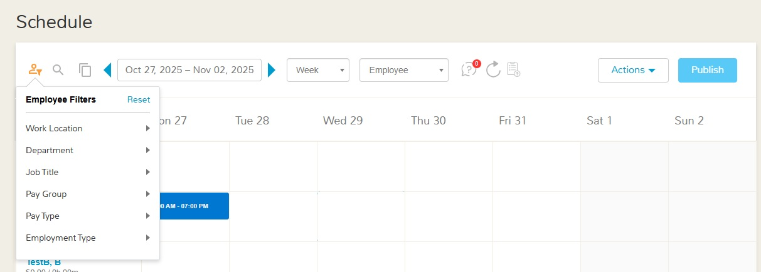

Search
A Search box is also available to find shifts for a specific employee by name; search is applied on top of any active filters, so you can, for example, search “John” within “Retail • Part-Time • Chicago” to see only matching rows.
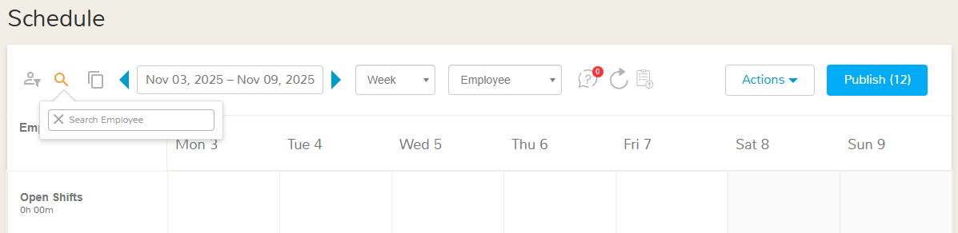

Different Views of Scheduler grid
The system provides multiple views of the scheduler grid and also facilitates the user to view the shifts of the desired employees.

Week
By default, the grid opens to the current week, with the week range shown at the top. Use the Left/Right arrows to move to earlier or later weeks; any active filters and search remain applied as you navigate. The layout is weekly: each column is a day (Mon–Sun), and each row represents a scope you choose—Employee, Work Location, or Job—so you can review coverage from different angles and drill into specific needs.
- Employee view: Each row is an employee; every cell shows that person’s shifts for the date in the column. Multiple shifts stack in the cell.
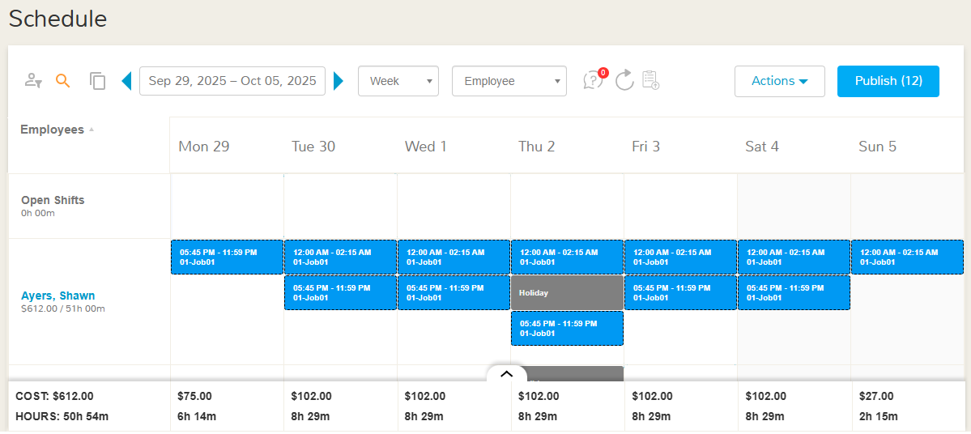
- Work Location view: Each row is a location; every cell lists shifts of all employees scheduled at that location, for the date.
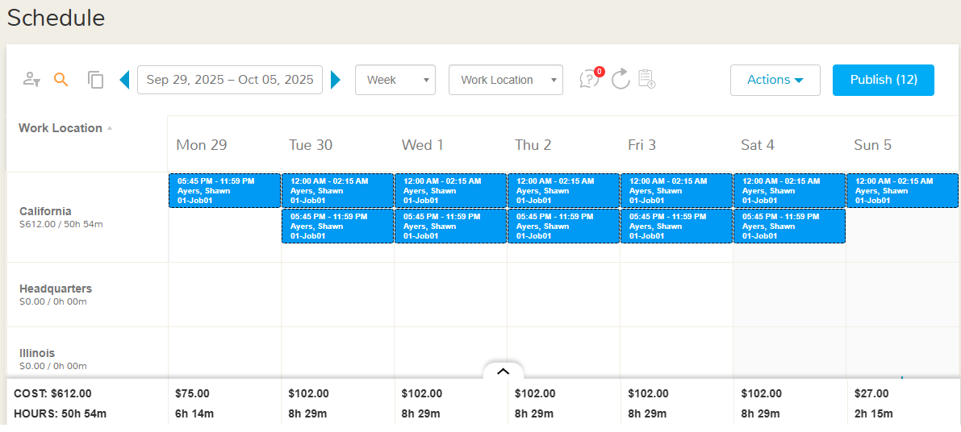
- Job view: Each row is a job; every cell shows all shifts tied to that job for the date, across locations. The row “Uncategorised Job” shows the shifts that are not tagged with any job.
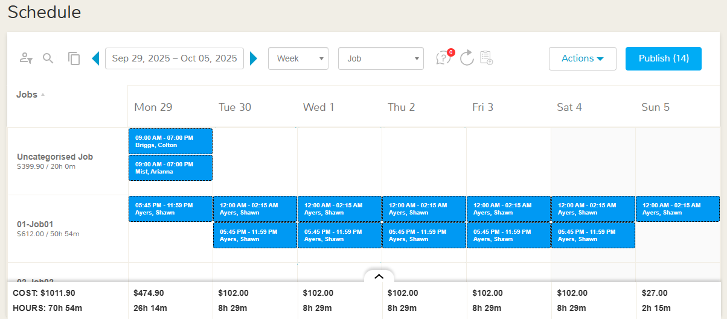

Month
The grid displays a monthly layout, where each cell represents a calendar day in the selected month. By default the current month opens. Within each day’s cell, the system lists all scheduled employee shifts for that date, allowing you to scan coverage and identify gaps at a glance. Use the Previous/Next arrows to move between months; your active filters and search criteria remain applied as you navigate.
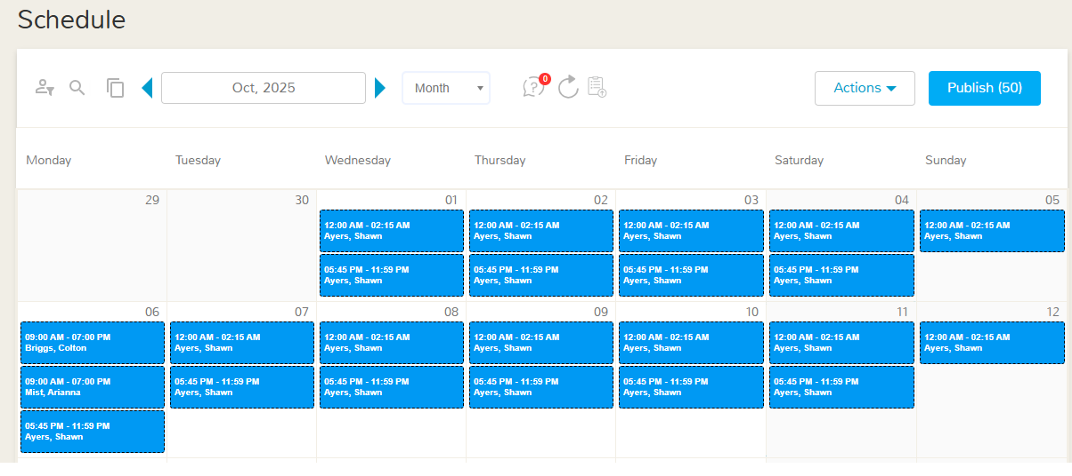

Day
By default, it opens today. You can move to the previous or next day using the arrow controls; your active filters and search criteria remain applied as you navigate.

The layout is daily: The grid uses a daily timeline with 12 columns, one for each 2 hours of the day. The column starts from 00:00 Hours and ends at 22:00 Hours. Each row represents a scope you choose—Employee, Work Location, or Job—so you can review coverage from different angles and drill into specific needs. Shifts are rendered as horizontal bars spanning the relevant hours—e.g., a 9:00 AM–5:00 PM shift covers eight columns from 9 through 17.
- Employee view: Each row is an employee; the shift bars in the row show the shifts for that employee on the selected day.
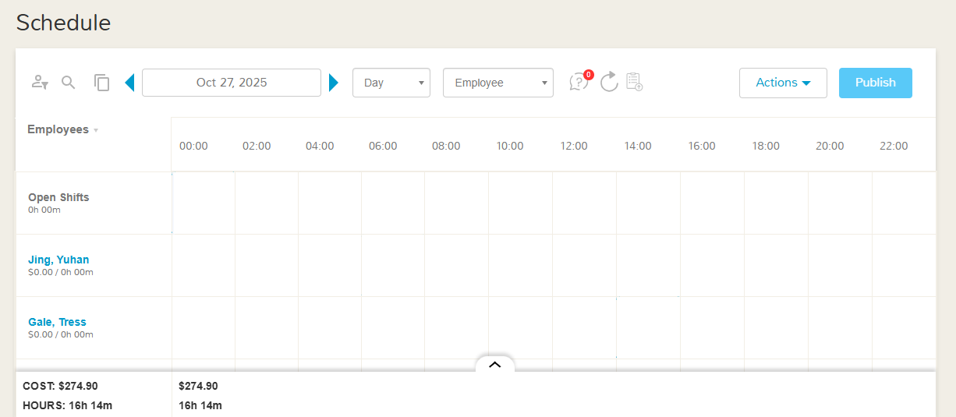
- Work Location view: Each row is a location; the shift bars in the row show the shifts for all employees of the location on the selected day.
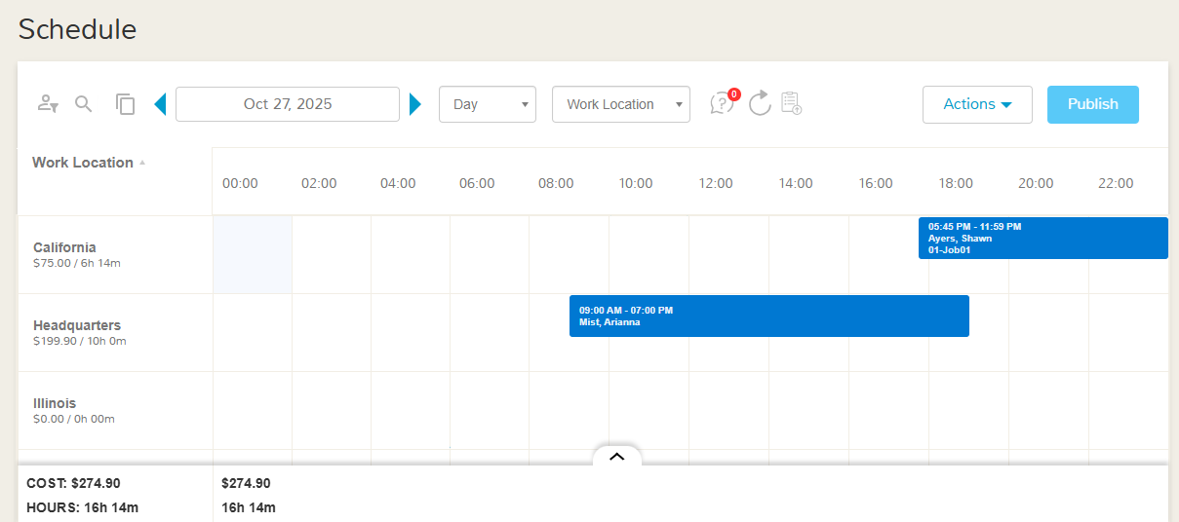
- Job view: Each row is a job; the shift bars in the row show the shifts for all employees which are tagged with the respective job on the selected day. The row “Uncategorised Job” shows the shifts that are not tagged with any job.
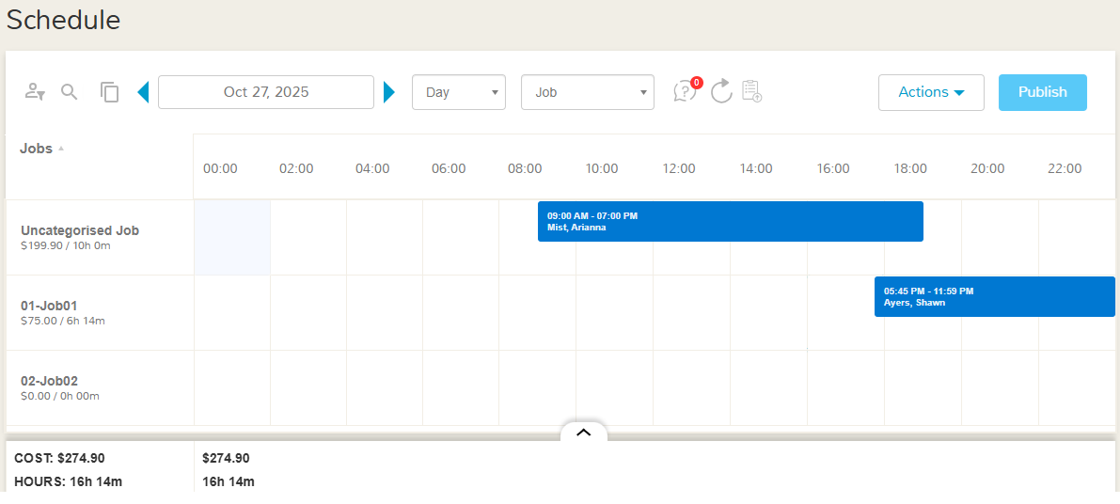

Show/Hide Cost

With the help of this feature, you can estimate the total cost of the assigned shifts. In the Day and Week view of the scheduler, the total cost appears on the bottom of each column. The total cost does not appear in the month view. You can show or hide the cost with the help of the actions “Show Cost”/”Hide Cost” from the action menu on the scheduler. How the cost is calculated
- If the shift is associated with a job, then the total cost of a shift is calculated by the no. of hours of the shift multiplied by the employee’s hourly pay rate of the respective job for the respective employee.
- If the shift is not associated with any job, then the total cost of a shift is calculated by the no. of hours of the shift multiplied by the employee’s hourly pay rate of the primary job (shown on the Job Page of the employee profile).
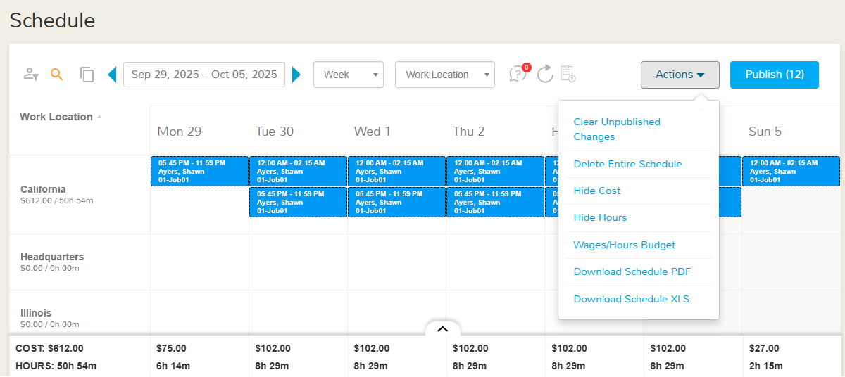

Show/Hide Hours
With the help of this feature, you can estimate the total hours of the assigned shifts. In the Day and Week view of the scheduler, the total hours appear on the bottom of each column. The total hours do not appear in the month view. You can show or hide the hours with the help of the actions “Show Hours”/”Hide Hours” from the action menu on the scheduler. To calculate the total hours, sum up the hours of all the shifts showing in the column.

Wages/Hours Budget
Scheduling managers will be able to set daily and weekly budgets for each work location by selecting “Wages/Hours Budget” from the Actions dropdown. While creating schedules, managers will be able to compare the estimated schedule costs with the set budget, ensuring better cost control.

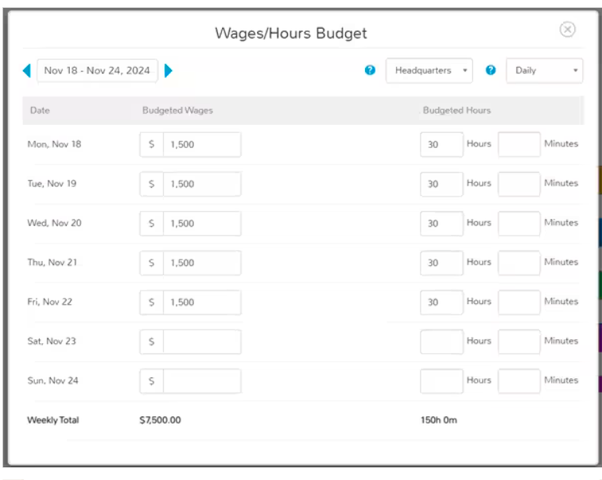
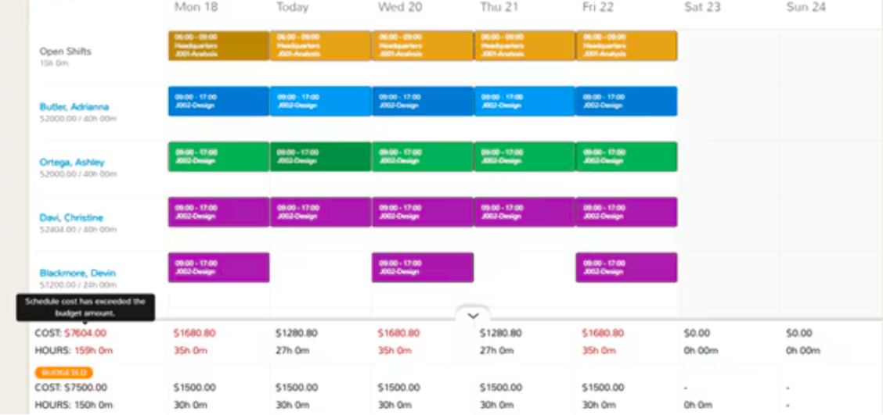

Creating Shift
Creating shifts on the “Schedule” page is a straightforward, quick, and intuitive process. To create a shift, you have two options: either double-click any cell within the scheduler or click the plus icon that appears when you hover over the cell. Once you initiate this shift creation action, the system will open the "Add Shift" window to capture the key attributes of the shift
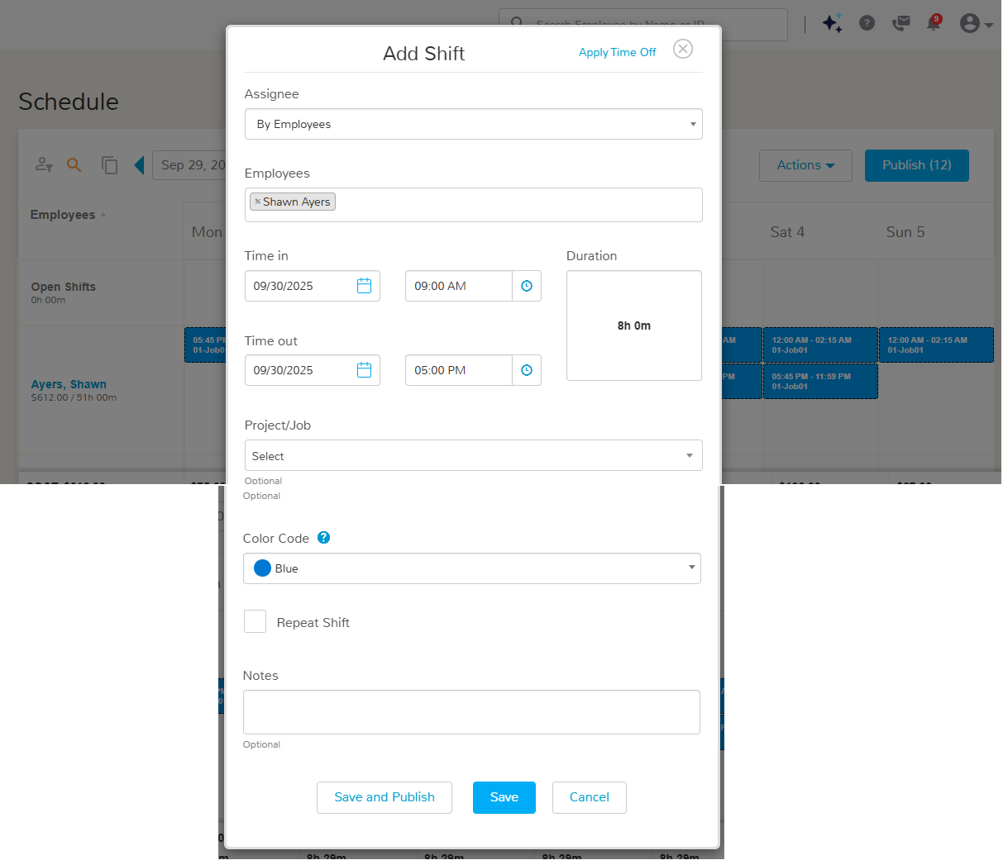

Creating Shift for specific employee
If you want to create a shift for a specific employee then under the input “Assignee” select “By Employees” and under the input “Employees” search for the employee for whom you want to create a shift.

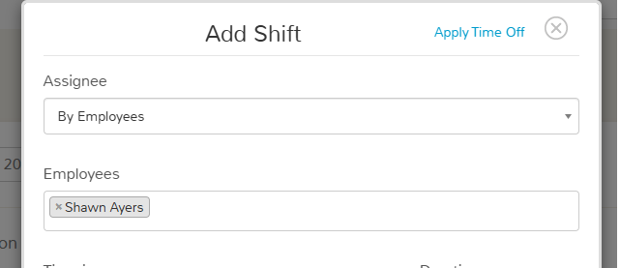

Creating Shift in bulk
To create shifts in bulk for multiple employees, UZIO allows you to generate them by Work Location, Department, or Pay Type, making scheduling faster and more efficient.
Under the “Assignee” field, select the desired grouping option — Department, Pay Type, or Work Location. Once selected, choose the specific values (for example, the departments or locations) for which you want to create shifts.
The system then automatically creates shifts for all active employees belonging to the selected departments, locations, or pay types who are already enabled for time tracking. This ensures that shifts are consistently applied across large groups without the need to manually create them one by one.
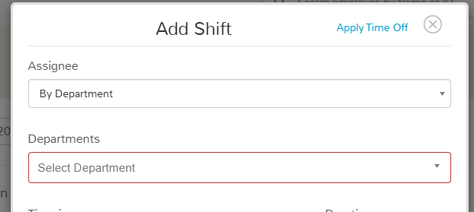
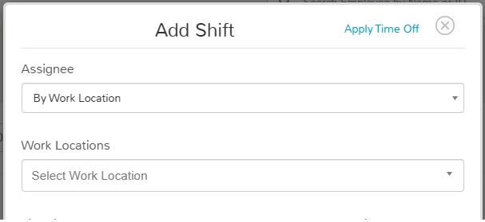

Time In/Time Out
Date and time of shift start and shift end.

Project/Job
You can tag a job—either part of a project or a standalone role—to a specific shift to ensure accurate job tracking. When a job is tagged to a shift, the employee is required to work under that job only while clocking in. The system automatically restricts them from selecting any other job during that shift, helping maintain accountability and reporting accuracy.
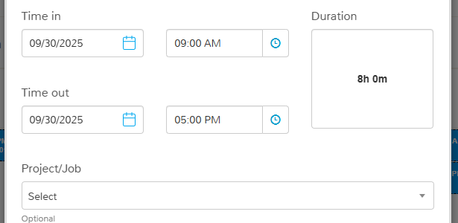
If you choose not to tag a job to a shift, employees will have the flexibility to select the appropriate job manually at clock-in, based on their task or assignment for the day. This setup gives employers the choice between strict job assignment control and flexible job selection, depending on operational needs.

Colour
You can give a color to shift, to distinguish between shifts of different departments, locations, job profile, employee etc, as per your requirement.
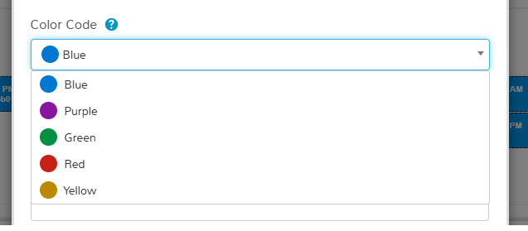

Creating Shifts for Multiple Days
To create shifts for multiple days in bulk, simply enable the “Repeat Shift” checkbox while creating a new shift. Once selected, choose the “Ends On” date and specify the days of the week (e.g., Monday, Wednesday, Friday) on which you want the shift to repeat.
This feature allows you to quickly generate recurring shifts for a defined period without manually creating each one. It’s especially useful for consistent scheduling patterns, such as weekly or bi-weekly shifts, ensuring efficiency and accuracy in large-scale shift planning.

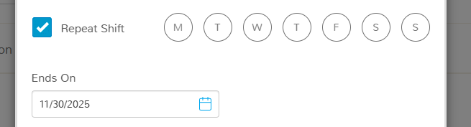

Notes
This is an optional field where you can add any additional comments or context related to the shift. It can include notes such as specific instructions, task details, reminders, or any other relevant information in text format that may help employees or managers understand the shift better.

Things to Note
- Just creating a shift does not make it available to track time, you need to publish as well.
- You can create shifts for any day, the system does not restrict you to create shifts on a holiday or time off day.
- You can not create overlapping shifts for any employee.
- You can create multiple shifts for an employee on a day.
- You can create overnight shifts as well.

Creating a Multi Day Shift
Employers can create shifts which start on one day and end on another. To do so, the employer needs to enter two different dates on the Add Shift pop up. If the employer is creating a multi day shift, the system will create two separate shifts, first ending at 11:59PM and another starting at 12:00 AM.

Schedule Import
UZIO provides an additional way to create shifts in bulk through the Schedule Import feature, allowing employers to quickly generate multiple shifts at once using an Excel template.
To import shifts in bulk, follow these steps:
- Navigate to Time Tracking from the left-hand menu.
- Go to Schedule and click the Schedule Import icon at the top of the page.
- The system will prompt you to download the Schedule Import template. Each row in this Excel sheet represents a single employee shift.
By default, the template includes all employees you have access to create shifts for, prepopulated with one shift for tomorrow. The start and end times in the sheet are based on your default shift settings under Schedule Settings.
You can modify the downloaded template to suit your needs — add or remove rows, adjust dates or timings, specify shift colors, or include notes. All shifts are created in blue color by default unless otherwise specified.
Once your updates are complete, upload the file back into the system. The upload process is asynchronous, meaning you can continue working elsewhere in UZIO while the file processes in the background. When the upload is complete, a confirmation message will appear at the top of the screen. If any issues occur, the system will provide an error file in the File Center, listing the rows and reasons for failure.
Important Notes:
- You can create shifts in bulk but cannot edit them in bulk.
- All imported shifts are initially created in an unpublished state — you must publish them before employees can start tracking time.
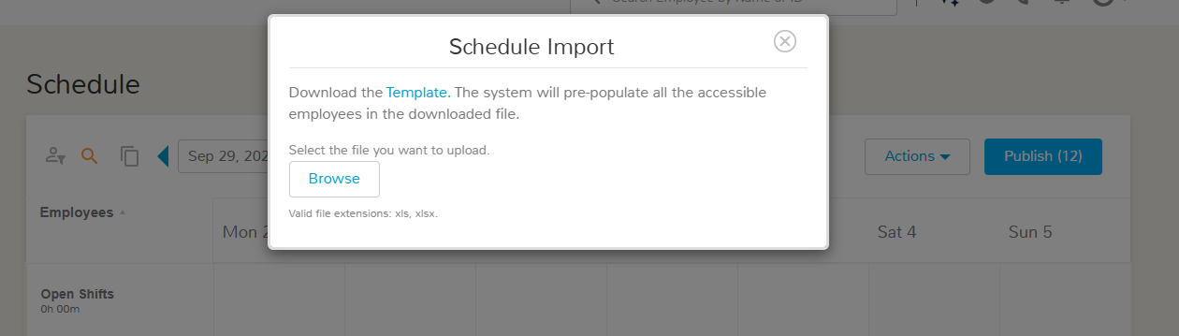

Publishing Shift
To publish shifts, you have two options depending on whether you want to publish a single shift or multiple at once.

Publishing a Specific Shift
To publish a specific shift, simply click directly on the shift in the scheduler grid and select the “Publish” action. The shift will immediately change to published status and become visible to the assigned employee for tracking.
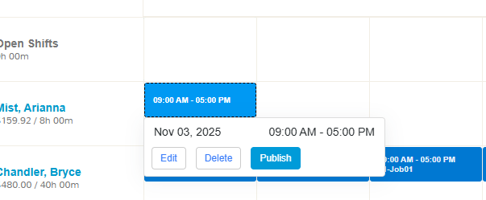

Publishing Shift in Bulk
To publish shifts in bulk, click the “Publish” button located at the top-right corner of the scheduler grid. This action will publish all unpublished shifts currently visible on your screen.
Note: If you’ve applied filters or search criteria that limit the view (for example, by department, job, or work location), only the shifts that are currently displayed on the grid will be published. To publish all shifts across the organization, make sure to clear filters and searches before using the bulk publish option.
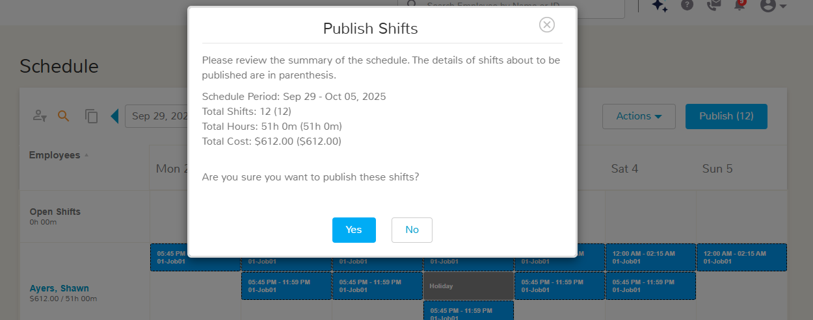

Overlap Detected
When publishing shifts in bulk, if the system detects that some shifts overlap with existing ones, it will publish all non-conflicting shifts and skip only the overlapping ones. After processing, UZIO will display a summary message indicating which specific shifts could not be published due to overlaps.
This helps ensure scheduling accuracy while still allowing valid shifts to go live immediately. You can review the flagged overlaps directly from the message, adjust the conflicting shifts, and then republish them once resolved.

Editing a Shift
You can edit an existing shift by clicking directly on it and selecting the “Edit” action. This opens the same window used for creating a new shift, where all shift details are displayed. From here, you can update any of the shift’s attributes—such as timing, assigned employee or job, or notes—and then save your changes. The updates take effect immediately and are reflected across all relevant schedule views.

Things to note
- You can edit both published and unpublished shifts, but shifts that already have recorded time entries cannot be modified to preserve data accuracy.
- While editing, you can change the shift date, but note that this effectively deletes the original shift for the current date and creates a new shift for the updated date. The system automatically enforces overlapping shift validations, ensuring that no employee is assigned two conflicting shifts for the same period.
- Additionally, you can reassign the shift to another employee, allowing managers to make adjustments quickly when staffing changes occur. All updates are applied instantly and reflected in the schedule view once saved.

Deleting Shift

Deleting an Specific Shift
To delete a specific shift, simply click directly on the shift in the scheduler grid and select the “Delete” action. The shift will immediately be deleted and become unavailable to the assigned employee for tracking.
You can delete both published and unpublished shifts, but shifts that already have recorded time entries cannot be deleted to preserve data accuracy.

Deleting Entire Schedule
To delete the entire schedule, including both published and unpublished shifts, choose the “Delete Entire Schedule” option from the Action menu at the top of the scheduler grid. This action removes all shifts within the currently displayed schedule view, allowing you to clear and rebuild it if needed.
However, the system does not delete any shift that already has time tracked by an employee, to preserve historical and payroll data integrity. Once the deletion is confirmed, all eligible shifts are permanently removed, and a confirmation message appears upon completion.
This action will delete all unpublished and published shifts currently visible on your screen.
Note: If you’ve applied filters or search criteria that limit the view (for example, by department, job, or work location), only the shifts that are currently displayed on the grid will be deleted. To delete all shifts across the organization, make sure to clear filters and searches before using the bulk delete option.

Clear Unpublished Changes
To delete only unpublished shifts, choose the “Clear Unpublished Changes” option from the Action menu at the top of the scheduler grid. This action removes all shifts within the currently displayed schedule view which are unpublished, allowing you to clear and rebuild it if needed.
However, the system does not delete any shift that already has time tracked by an employee, to preserve historical and payroll data integrity.
Note: If you’ve applied filters or search criteria that limit the view (for example, by department, job, or work location), only the shifts that are currently displayed on the grid will be deleted. To delete all shifts across the organization, make sure to clear filters and searches before using the bulk delete option.

Download Schedule
You can download the schedule in two ways- as PDF or as Excel Sheet.

Download as PDF
When you use the Download Schedule as PDF action, UZIO exports the entire scheduler grid into a PDF file for easy sharing and recordkeeping. The generated PDF includes all shift types currently displayed on the scheduler — published shifts, unpublished shifts, and open shifts.
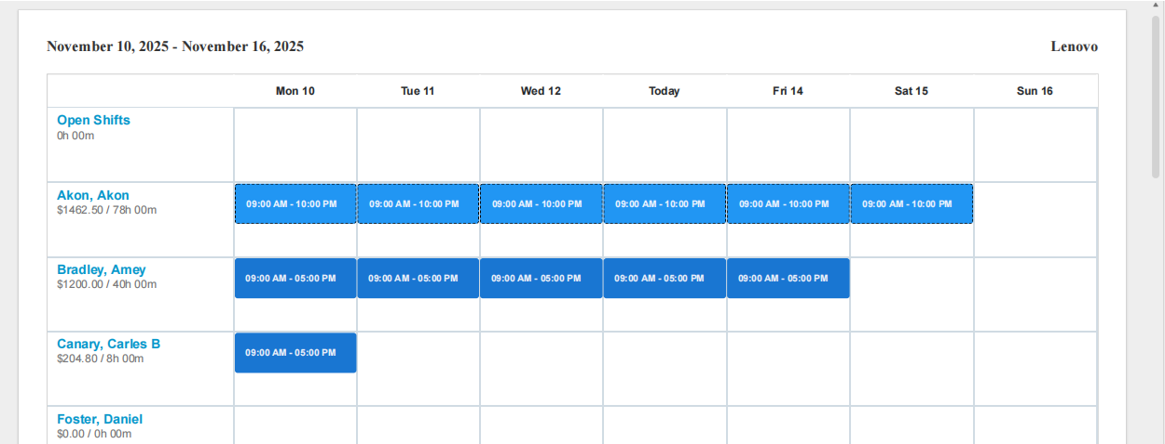

Download as XLS
When you use the Download Schedule XLS action, UZIO exports the current schedule into an Excel file. Upon initiating this action, the system generates the report in the background and displays a confirmation message at the top of the screen with a download link once the file is ready.
When exporting the schedule, UZIO automatically runs the Shift Assignment Report in the background with the selection criteria set to “By Employees.” The report includes only the employees currently visible on the scheduler grid, respecting any filters or searches applied.
You can also access and download this same report anytime from the Reports section for future reference or further analysis. This feature ensures you have a quick, organized view of all scheduled shifts in a structured Excel format.
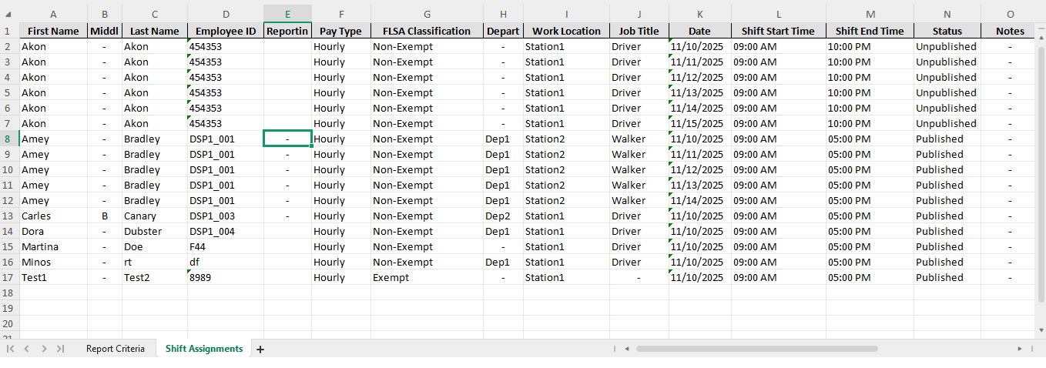

Copy Shift
You can copy existing shifts quickly using the “Copy” icon located at the top of the scheduler grid. Once you click on it, the system will prompt you to choose one of the following options based on how you want to duplicate your schedule:

Copy to Next
Duplicates all shifts currently displayed on the scheduler grid and copies them to the next day, week, or month, depending on the active scheduler view.

Copy from Previous
Pulls shifts from the previous day, week, or month and replicates them into the current period of the scheduler grid.

Advanced Option
Gives you full flexibility to copy shifts from any prior day, week, or month to any future day, week, or month. You can select both the source and destination periods from dropdown lists to control exactly where shifts are duplicated.
This feature is especially useful for maintaining consistent scheduling patterns across periods, reducing manual effort and ensuring quick adjustments to recurring workforce plans.

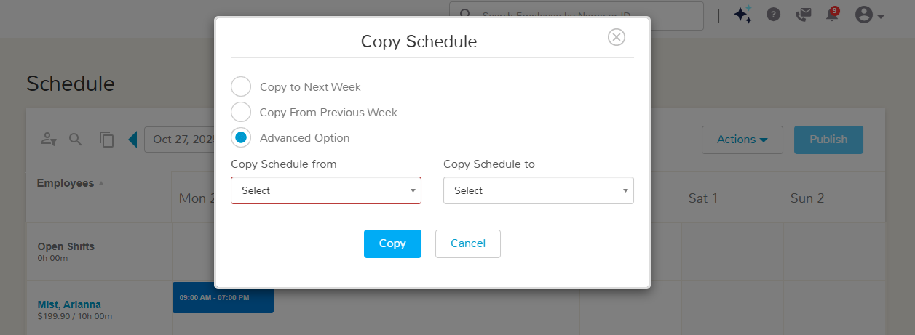

Open Shift

What is Open Shift
An Open Shift is a shift that is not assigned to any specific employee and is available for eligible employees to claim.
Open shifts can be created for one or more work locations, and any active employee belonging to those locations can view and claim them based on availability. Once claimed and approved, the shift becomes assigned to that employee and follows the same tracking and approval flow as a regular shift.

Creating an Open Shift
To create an open shift, you can either double-click any cell within the scheduler grid or click the plus (+) icon that appears when you hover over a cell. This opens the shift creation window.
In the pop-up, under the “Assignee” dropdown, select “Open Shift”. Then, under the Work Location dropdown, choose one or more locations where you want the open shift to be available. If you are selecting multiple locations, the system will create one shift for each work location. Employees associated with the selected locations will be able to view and claim these shifts.
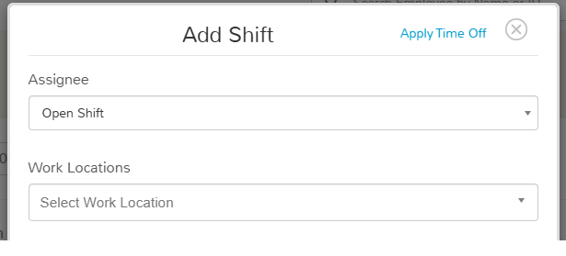

Claiming an Open Shift
Employees can claim open shifts directly from the mobile app—this functionality is not available on the web.
To claim an open shift, follow these steps:
- Log in to the UZIO mobile app as an employee.
- Tap Schedule from the bottom navigation bar.
- Select Open Shifts and click on “Available Shifts” to view all available unassigned shifts for your work location(s).
- Tap the Claim link next to the shift you wish to take.
Once claimed, the request is sent to the admin for approval. After approval, the shift becomes assigned to the employee and appears in their My Shifts.

Subject: Open shift claim request
Body: Hello James,
You have received a claim request for the following open shift:
Shift details:
Location: Station1
Shift Time: 09:00 AM - 05:00 PM
Shift Day and Date: Friday, Nov 14, 2025
Requester's Comments:
Requested By: Amey Bradley
Click here to approve or reject this request.
Thank you
Team Uzio
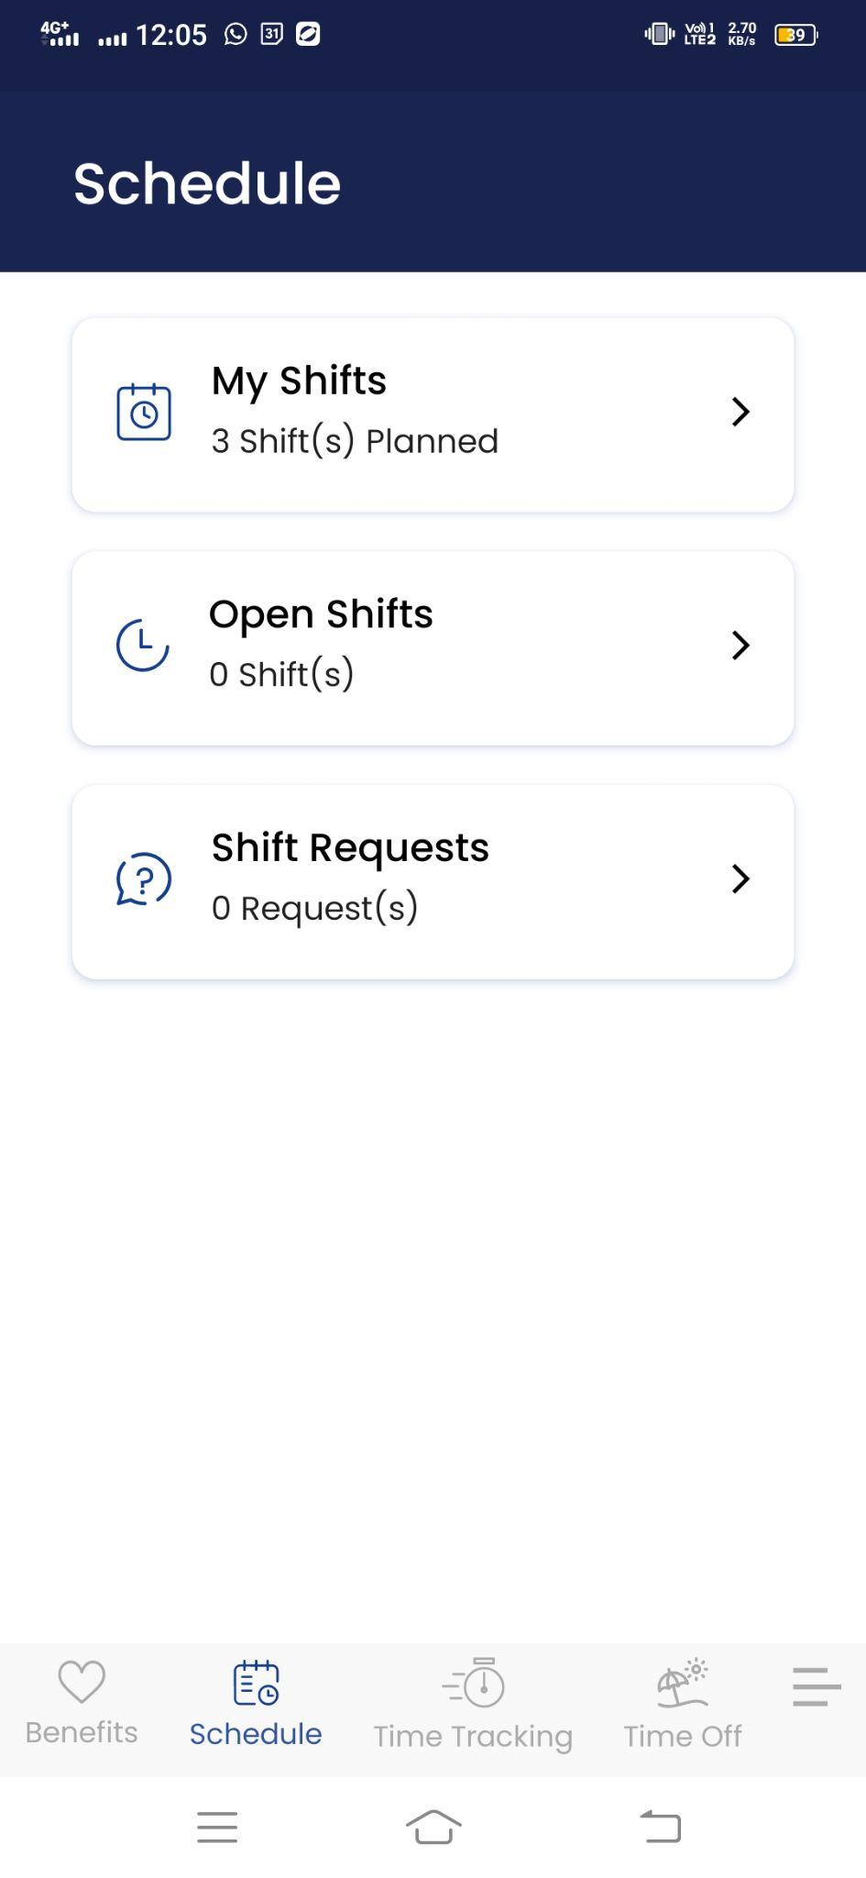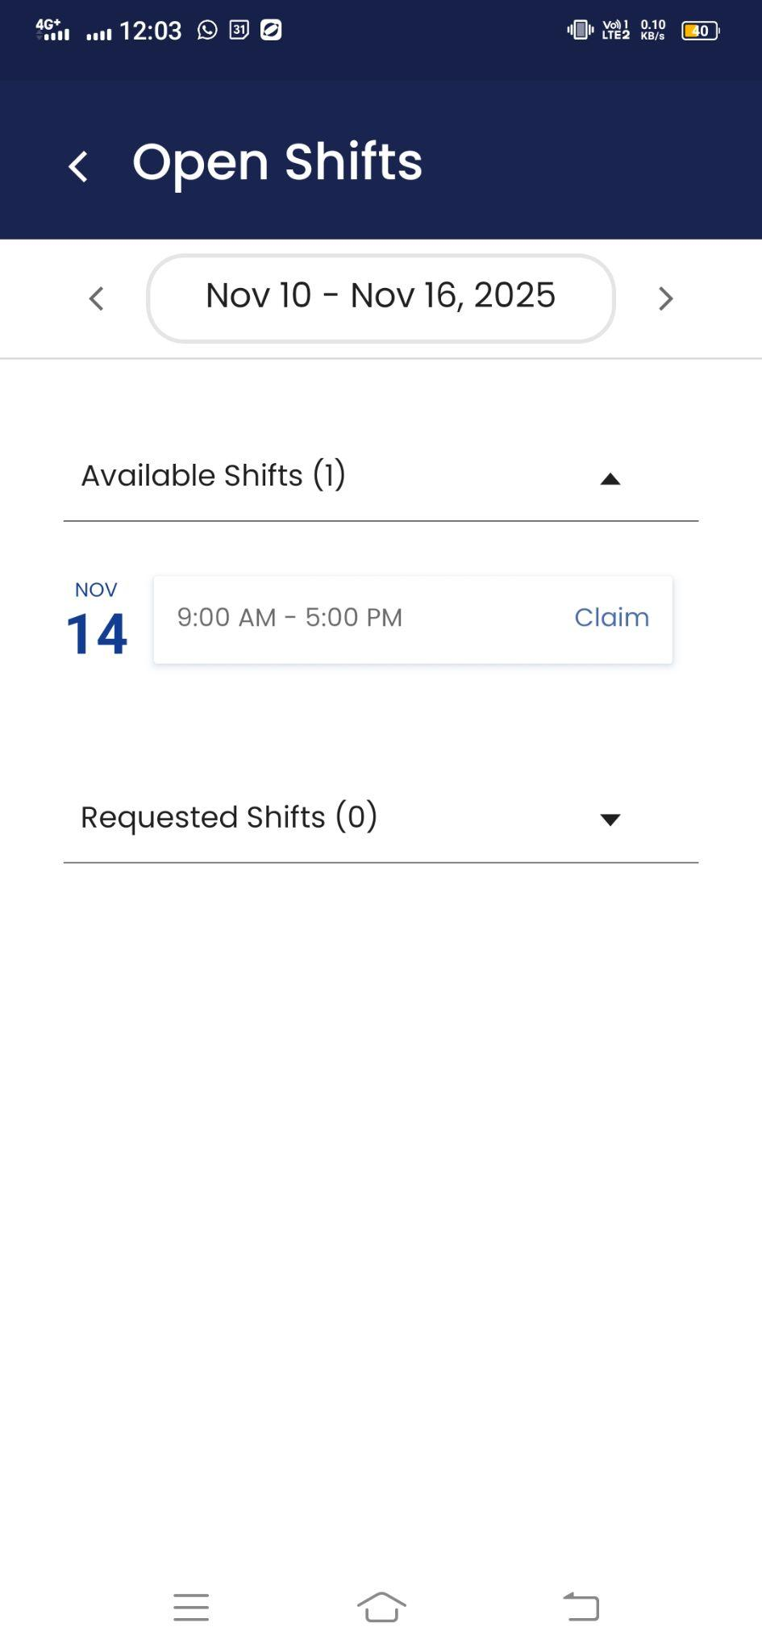

Viewing or Cancelling the Claimed Shifts
Employees can view or cancel a claimed shift directly from the mobile app.
To do this:
- Log in to the UZIO mobile app as an employee and tap Schedule from the bottom navigation bar.
- Click on the Open Shifts and go to Requested Shifts. It will show all the claimed shifts that are not yet approved.
- Tap the three-dot menu next to the shift and select “Cancel Request.”
- This removes the claim and makes the shift available again for other eligible employees to claim.

Accepting/Rejecting Shift Claim
Admins can accept open shift claims directly from the scheduler. Until admins do not approve, the shift is not available to employees. To do so
- Click on the shift and select the “Claims” action.
- A window will appear showing a list of employees who have requested to claim that shift.
- From this view, you can either Accept or Reject each request.
- Once Accepting a request for one employee, the system will automatically reject all other pending requests for that shift and assign it to the employee you approved.
- The system will notify employees for whom the claim is accepted as well as for whom the claim is rejected.
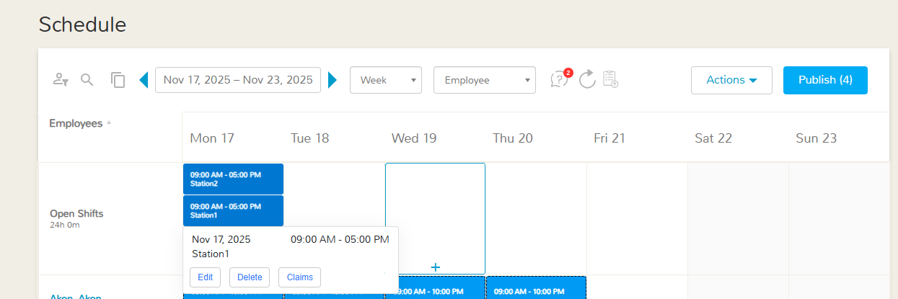
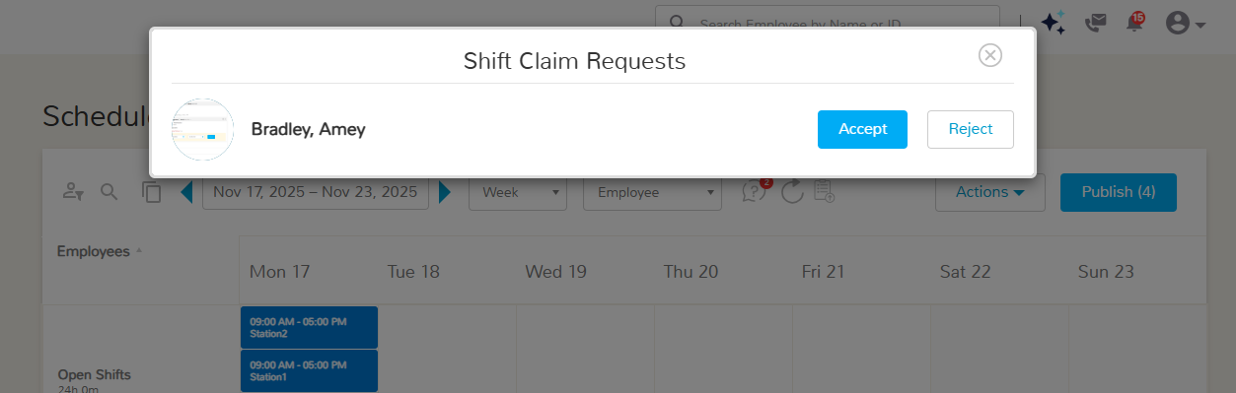

Sample Email: Open shift claim request approved
James has accepted your claim to the below shift, and it is now assigned to you.
Shift details:
Location: Station1
Shift Time: 09:00 AM - 05:00 PM
Shift Day and Date: Monday, Nov 17, 2025
Login to your mobile app to see your updated upcoming shifts or click here to see your updated schedule.
Thank you
Team Uzio

Swap Shift

What is swapping a shift
A Shift Swap is a process that allows two employees to exchange their assigned shifts, subject to manager approval. This feature helps employees to manage schedule conflicts or personal needs while ensuring coverage continuity.
It’s important to note that employees can only swap shifts with others working at the same work location. Once a swap request is submitted and accepted by another employee, the admin reviews it and can approve or reject the swap. After approval, the system automatically updates both employees’ schedules to reflect the exchanged shifts.

How to Swap a Shift
Employees can swap a shift, directly from the mobile app—this functionality is not available on the web.
To swap the assigned shift, follow these steps:
- Log in to the UZIO mobile app as an employee and tap Schedule from the bottom navigation bar.
- Select My Shifts to view all assigned shifts and click on the “Swap” link.
- It opens a window where employees can see the shifts of all other employees of the same work location.
- Employees can select one or more shifts of their choice and click on the “Swap Shift” button to send the request to the selected employees.
- The selected employees will receive an email as well as push notification about the shift swap request.
Subject: Shift swap request
Hello Amey,
Carles has requested to swap their shift with yours. Below are the shift details
Carles's shift details:
Shift Time: 09:00 AM - 03:00 PM
Shift Day and Date: Saturday, Nov 15, 2025
Requester's Comments:
Your shift details:
Shift Time: 09:00 AM - 05:00 PM
Shift Day and Date: Saturday, Nov 15, 2025
Login into your mobile app to accept or reject this request.
Thank you
Team Uzio
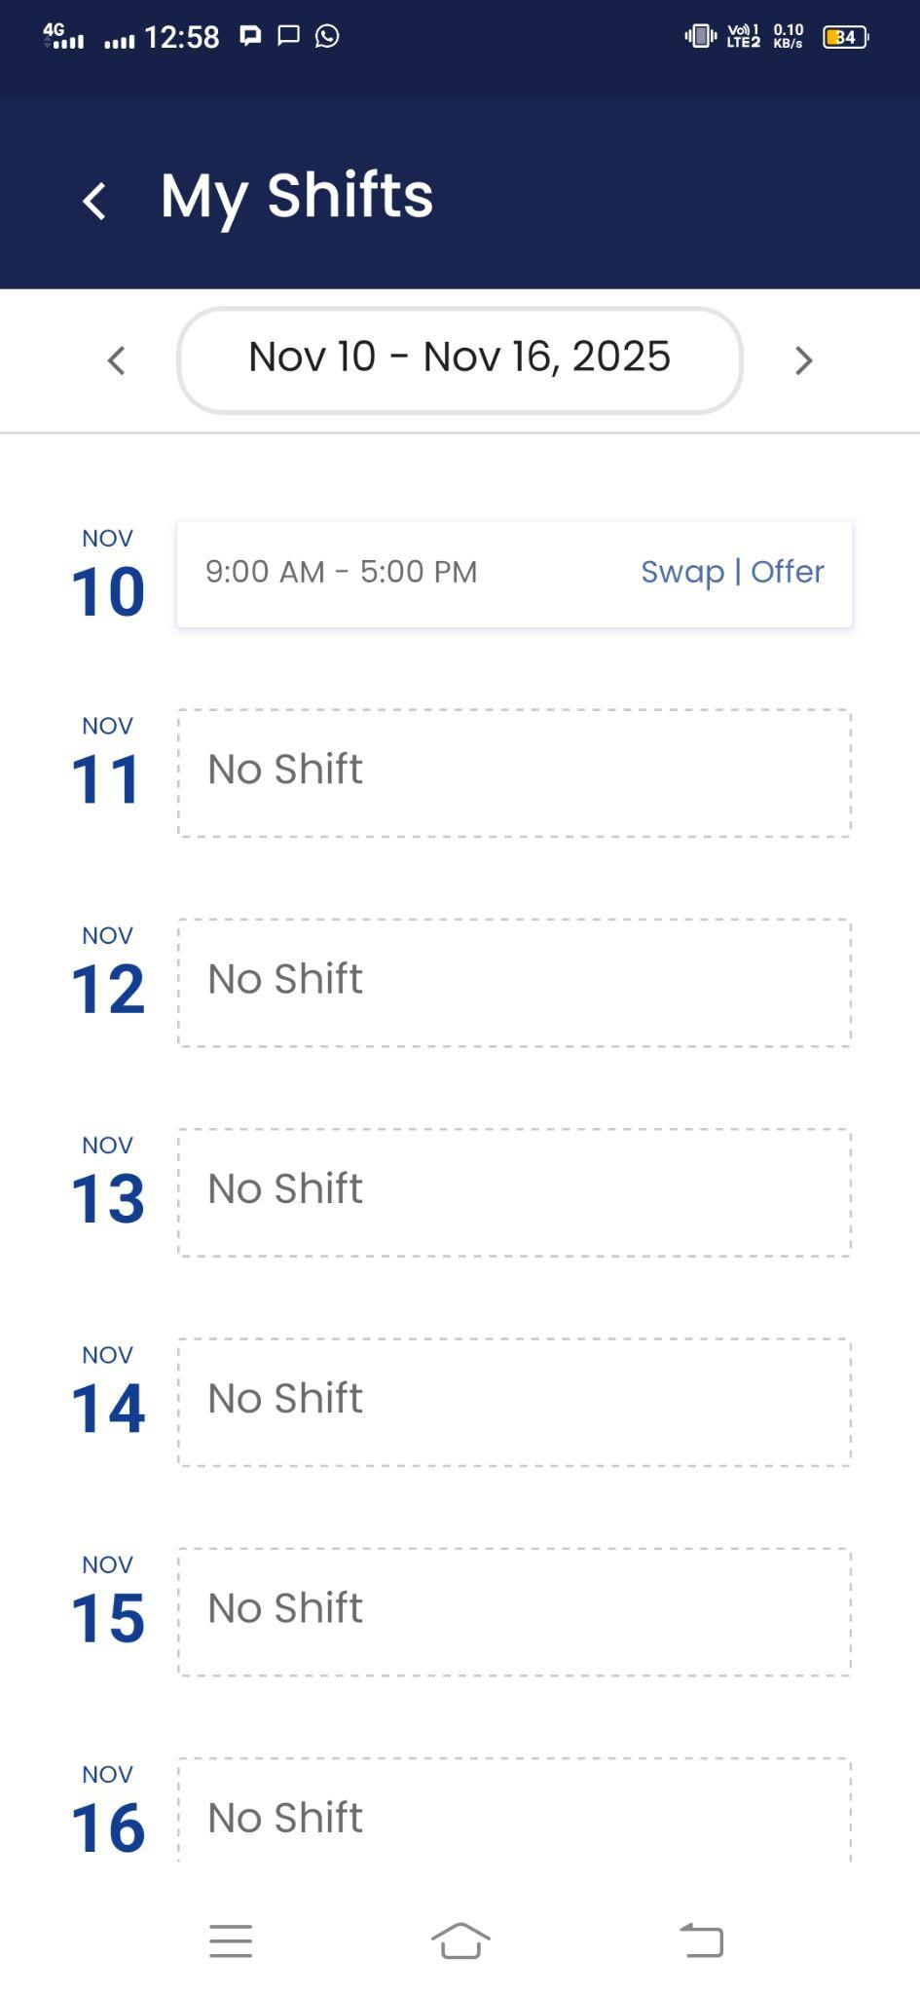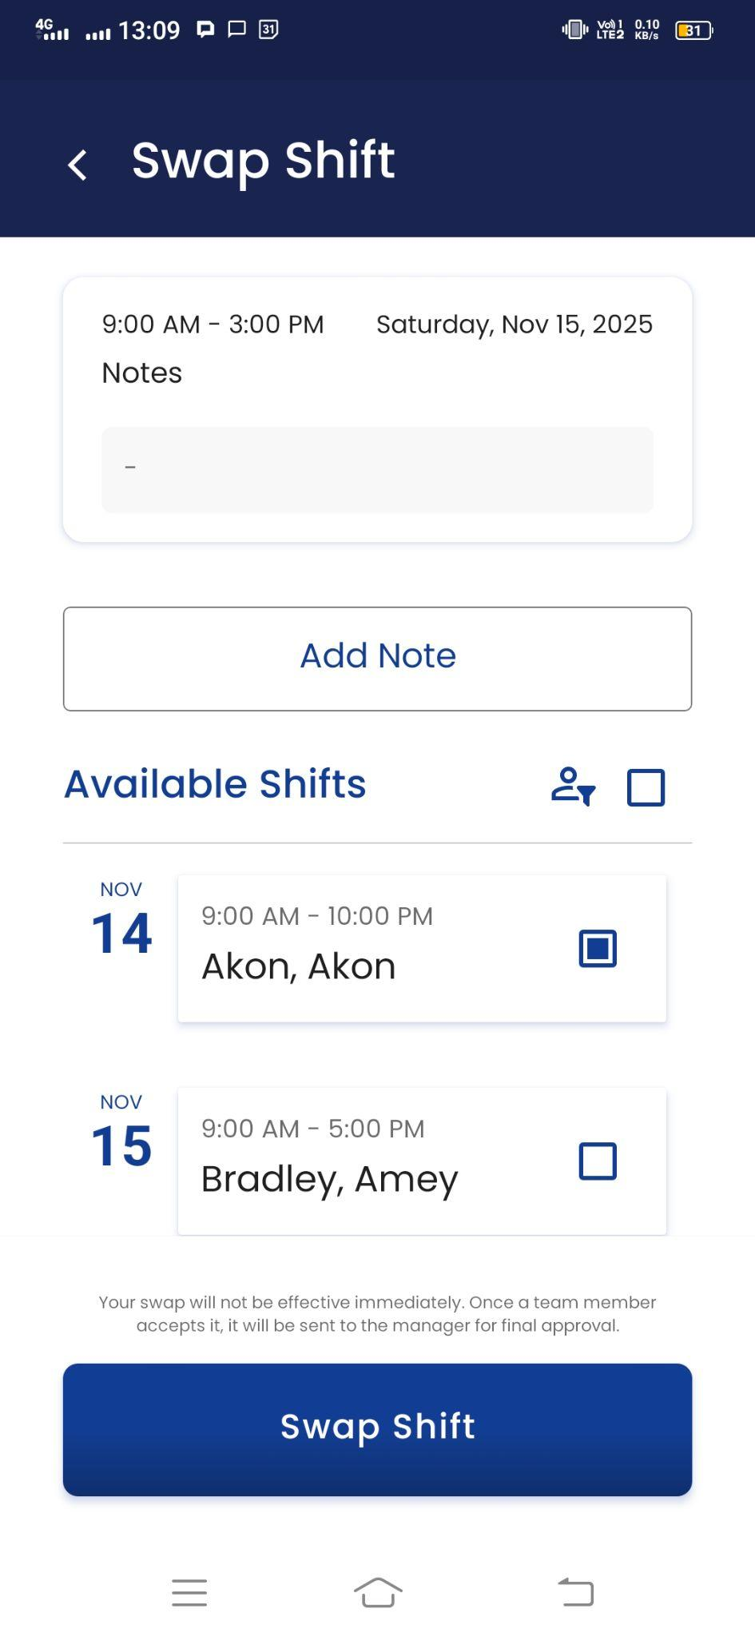

Viewing or Cancelling Your Own Swap Shift Requests
Employees can view or cancel their own swap shift request directly from the mobile app.
To do this:
- Log in to the UZIO mobile app as an employee and tap Schedule from the bottom navigation bar.
- Click on the Shift Requests and go to Swap and open the “Your Requests"
- It will show all the swap shifts requests that you have made and not yet approved by the admin.
- Tap the three-dot menu next to the shift and select “Cancel Request.”
This removes the swap request and keeps the original shift assignment as it is.

Accepting/Rejecting the Shift Swap Request

When an employee requests for swapping the shift, the other employee needs to accept/reject the request. To accept/reject the request, follow the steps below
- Log in to the UZIO mobile app as an employee and tap Schedule from the bottom navigation bar.
- Click on the Shift Requests and go to Swap
- Open the “Incoming Requests" and click on the shift that is being requested to swap.
- Click on the “Accept” button to accept the request and “Reject” button to reject the request.
- Once an employee accepts a shift swap request, the requestor receives a notification confirming the acceptance. At the same time, the admin is also notified of the pending shift swap approval.
- In the same way, if the employee rejects the shift swap request, the requestor receives a notification confirming the rejection.
Notification to Requestor on Accepting the request
Shift swap request sent for manager’s approval
Hello Carles,
Amey has accepted your shift swap request. It is now pending for the manager’s approval.
Below are the shift details
Your shift details:
Shift Time: 09:00 AM - 03:00 PM
Shift Day and Date: Saturday, Nov 15, 2025
Amey's shift details:
Shift Time:09:00 AM - 05:00 PM
Shift Day and Date: Saturday, Nov 15, 2025
Thank you
Team Uzio
Notification to Requestor on Rejecting the request
Subject: Shift swap request rejected
Hello Carles,
Amey has rejected your shift swap request.Below are the shift details
Your shift details:
Shift Time: 09:00 AM - 03:00 PM
Shift Day and Date: Saturday, Nov 15, 2025
Requester's Comments:
Amey's shift details:
Shift Time:09:00 AM - 05:00 PM
Shift Day and Date: Saturday, Nov 15, 2025
Rejecter's Comments: Thanks
Thank you
Team Uzio

Notification to admin on Accepting the request
Subject: Shift swap request
Hello James,
You have received the following shift swap request:
Carles B Canary shift details:
Shift Time: 09:00 AM - 03:00 PM
Shift Day and Date: Saturday, Nov 15, 2025
Requester's Comments:
Amey Bradley shift details:
Shift Time: 09:00 AM - 05:00 PM
Shift Day and Date: Saturday, Nov 15, 2025
Accepter's Comments: Thanks
Click here to approve or reject this request.
Thank you
Team Uzio
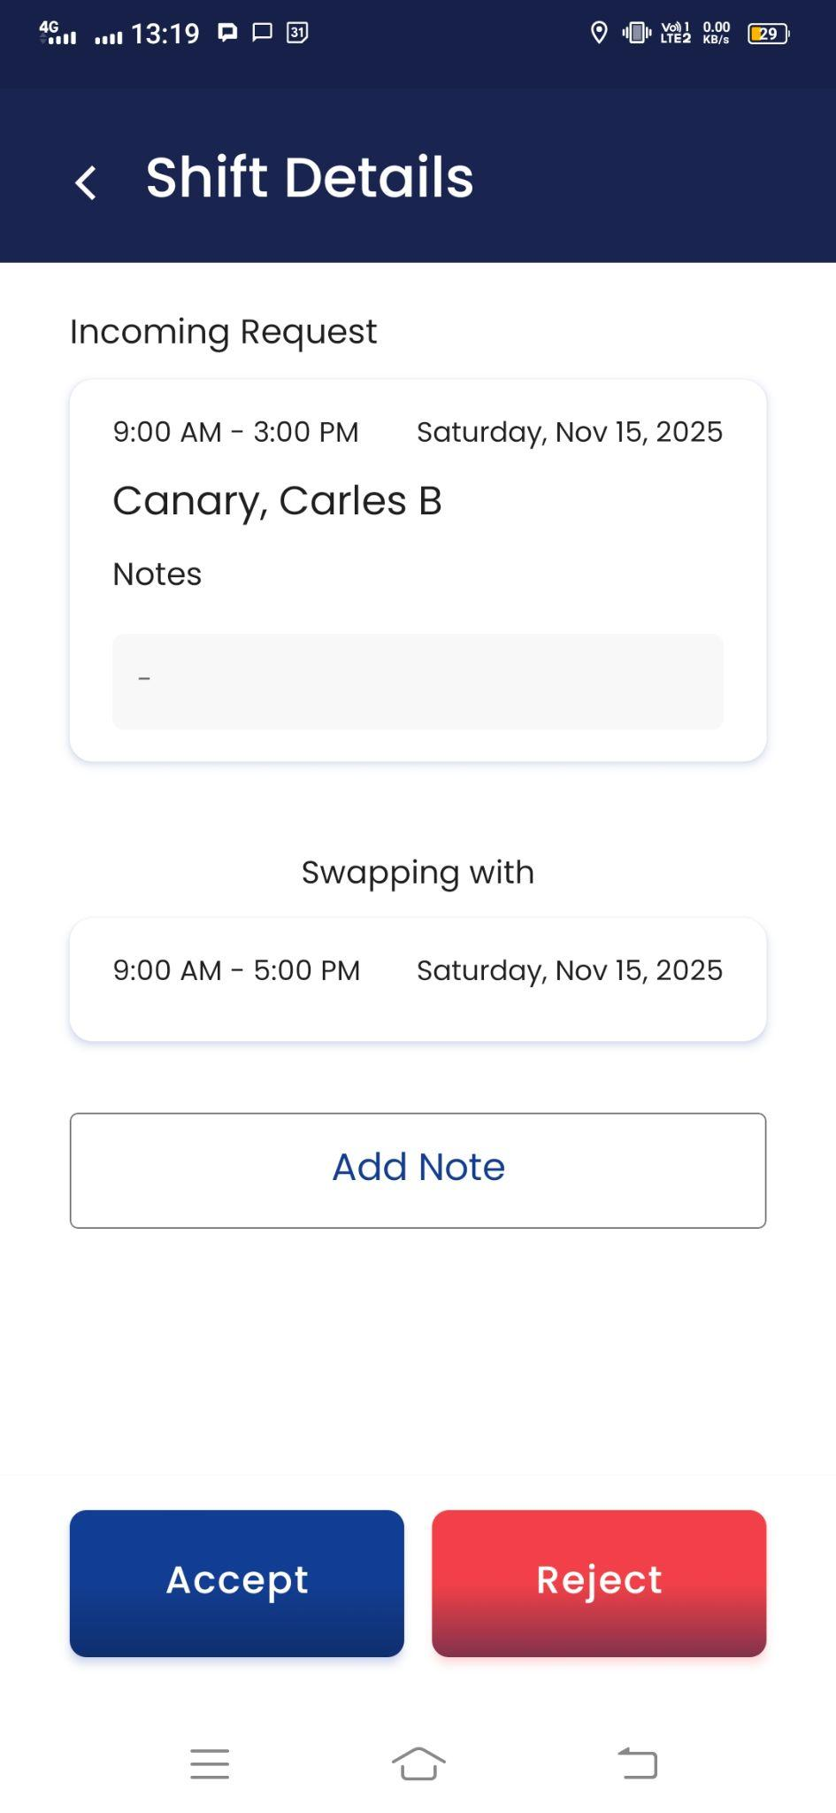

Cancelling an Accepted Shift Swap Request
Once the employee has accepted the shift swap request, they can change their decision and cancel the accepted shift swap request. Follow the steps below to cancel the accepted swap request. Employees can cancel an accepted shift swap directly from the mobile app
- Log in to the UZIO mobile app as an employee and tap Schedule from the bottom navigation bar.
- Click on the Shift Requests and go to Swap.
- Open the “Incoming Requests" and locate the accepted shift request.
- Tap the three-dot menu next to the shift and select “Cancel Request.”
- Once cancelled, the requestor will receive the notification about the same.
Subject: Shift swap request rejected
Hello Amey,
Carles has rejected your shift swap request.Below are the shift details
Your shift details:
Shift Time: 09:00 AM - 05:00 PM
Shift Day and Date: Saturday, Nov 15, 2025
Requester's Comments:
Carles's shift details:
Shift Time:09:00 AM - 03:00 PM
Shift Day and Date: Saturday, Nov 15, 2025
Rejecter's Comments:
Thank you
Team Uzio

Approving/Rejecting Shift Swap Request by Admin
Admins can approve or reject shift swap requests directly from the scheduler. Shifts are not exchanged until the admin approves the request. To review pending requests:
- Login as Employer on the Employer portal.
- Click the “Needs Approval” icon on the scheduler.
- Select “Shift Swap Requests.”
- A window will appear showing the employees involved in each swap request.
- From here, the admin can Accept or Reject the swap.
- Once a decision is made, both employees are notified via email and push notification, ensuring transparency and timely updates.

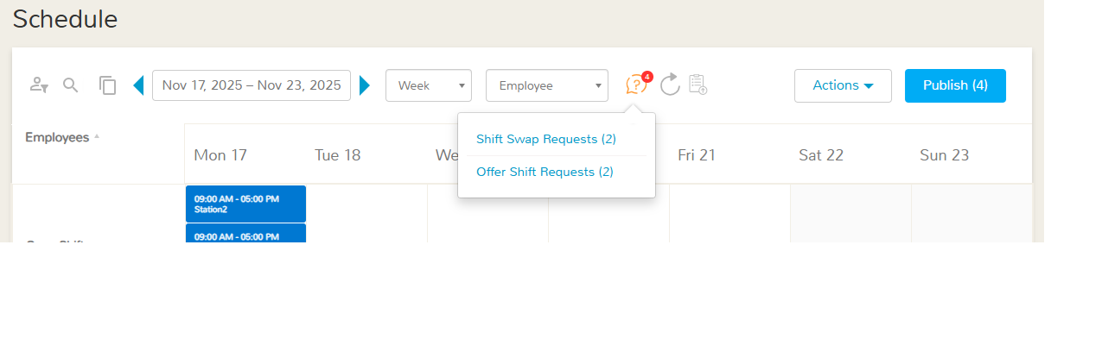
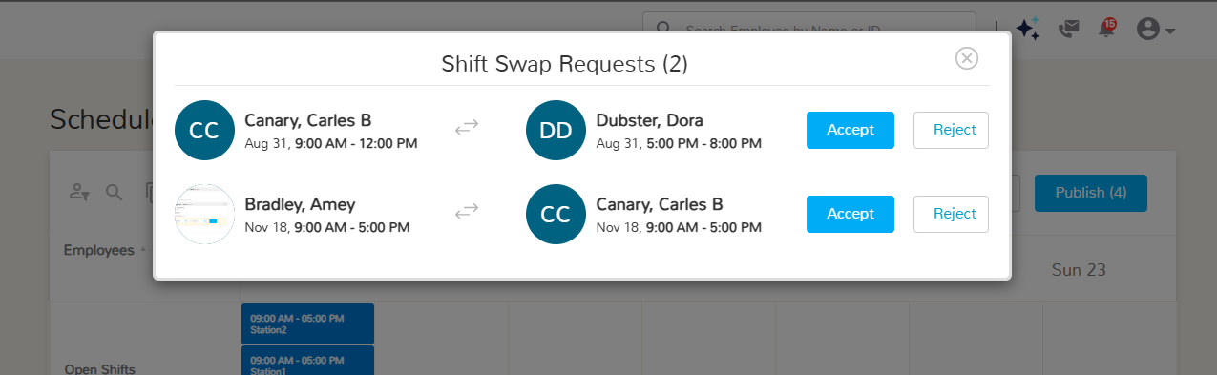

Notification to Employees on Accepting the Swap shift request by Admin

Sample Email- Shift swap request approved
DSP has accepted the below shift swap request
Amey's shift details:
Shift Time: 09:00 AM - 05:00 PM
Shift Day and Date: Tuesday, Nov 18, 2025
Requester's Comments:
Carles's shift details:
Shift Time: 09:00 AM - 05:00 PM
Shift Day and Date: Tuesday, Nov 18, 2025
Shift Job: 002-Secondary
Accepter's Comments:
Login to your mobile app to see your updated upcoming shifts or click here to see your updated schedule.
Thank you
Team Uzio

Notification to Employees on Rejecting the Swap shift request by Admin
Sample Email - Shift swap request rejected
James has rejected the below shift swap request
Carles’s shift details:
Shift Time:09:00 AM - 12:00 PM
Shift Day and Date: Sunday, Aug 31, 2025
Requester's Comments:
Dora's shift details:
Shift Time:05:00 PM - 08:00 PM
Shift Day and Date: Sunday, Aug 31, 2025
Accepter's Comments:
There is no change in your schedule.
Login to your mobile app to see your upcoming shifts or click here to see your schedule.
Thank you
Team Uzio

Offer Shift

What is Offering a Shift
Offering a shift is a process in which one employee can offer a shift to any other employee of the same work location who does not have any assigned shift, subject to admin approval.
It’s important to note that employees can only offer shifts to others working at the same work location. Once an offer shift request is submitted and accepted by another employee, the admin reviews it and can approve or reject the request. After approval, the system automatically updates both employees’ schedules to reflect the offered shifts.

How to Offer a Shift
Employees can offer a shift, directly from the mobile app—this functionality is not available on the web.
To offer the assigned shift, follow these steps:
- Log in to the UZIO mobile app as an employee and tap Schedule from the bottom navigation bar.
- Select My Shifts to view all assigned shifts and click on the “Offer” link.
- It opens a window that allows them to select one or more coworkers from the same work location to whom they want to offer their shift.
- Click on the “Offer Shift” button to send the request to the selected employees.
- The selected employees will receive a notification about the shift offer request.
Subject: Shift offer request
Hello Dora,
Carles has offered you the below shift:
Shift Time: 09:00 AM - 03:00 PM
Shift Day and Date: Saturday, Nov 15, 2025
Requester's Comments:
Login into your mobile app to accept or reject this request.
Thank you
Team Uzio
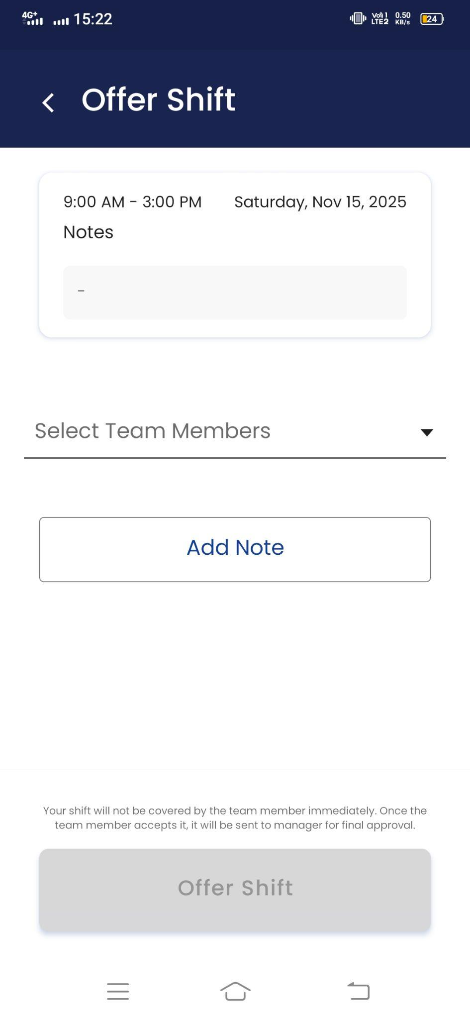

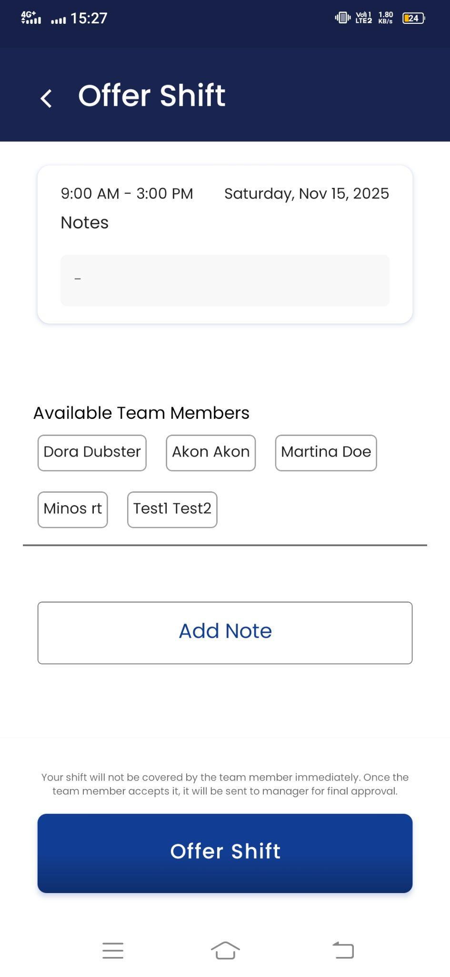

Viewing or Cancelling Your Own Offer Shift Requests
Employees can view or cancel their own offer shift request directly from the mobile app.
To do this:
- Log in to the UZIO mobile app as an employee and tap Schedule from the bottom navigation bar.
- Click on the Shift Requests and go to Offer and open the “Your Requests"
- It will show all the offer shifts requests that you have made and not yet approved by the admin.
- Tap the three-dot menu next to the shift and select “Cancel Request.”
This removes the offer request and keeps the original shift assignment as it is.

Accepting/Rejecting the Shift Offer Request
When an employee offers a shift, the other employee needs to accept/reject the request. To accept/reject the request, follow the steps below
- Log in to the UZIO mobile app as an employee and tap Schedule from the bottom navigation bar.
- Click on the Shift Requests and go to Offer
- Open the “Incoming Requests" and click on the shift that is being offered.
- Click on the “Accept” button to accept the request and “Reject” button to reject the request.
- Once an employee accepts an offered shift, the requestor receives a notification confirming the acceptance. At the same time, the admin is also notified of the pending approval.
- In the same way, if the employee rejects the offered shift, the requestor receives a notification confirming the rejection.
Notification to Requestor on Accepting the offer by other employee
Subject: Shift offer request sent for manager’s approval
Hello Carles,
Dora has accepted your shift offer. It is now pending for the manager’s approval. Below are the shift details
Your shift details:
Shift Time: 09:00 AM - 03:00 PM
Shift Day and Date: Saturday, Nov 15, 2025
Requester's Comments:
Thank you
Team Uzio
Notification to Requestor on Rejecting the offer by other employee
Subject: Shift offer request rejected
Hello Carles,
Dora has rejected your shift offer.
Below are the shift details
Your shift details:
Shift Time: 09:00 AM - 03:00 PM
Shift Day and Date: Saturday, Nov 15, 2025
Requester's Comments:
Thank you
Team Uzio
Notification to Admin on Accepting the offer by other employee
Subject: Shift Offer request
Hello DSP,
You have received the following shift offer request:
Shift details:
Shift Time: 09:00 AM - 03:00 PM
Shift Day and Date: Saturday, Nov 15, 2025
Requester's Comments:
Original Assignee: Carles B Canary
New Assignee: Dora Wright
Click here to approve or reject this request.
Thank you
Team Uzio

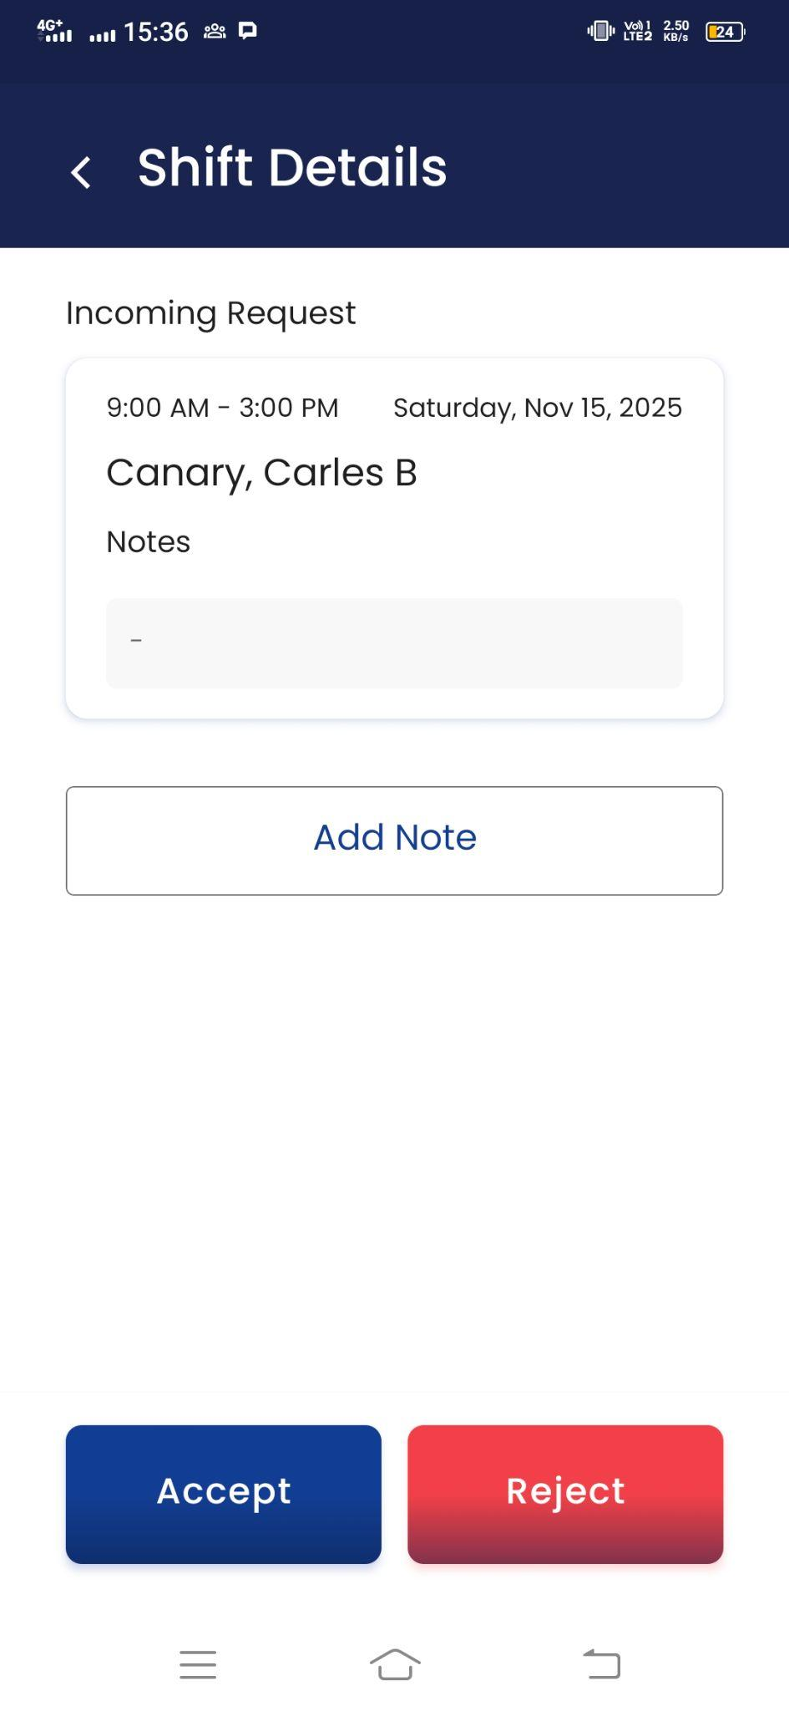

Cancelling the Accepted Shift Offer Request
Once the employee has accepted the offered shifts, they can change their decision and cancel the accepted request. Follow the steps below to cancel the accepted request. Employees can cancel an accepted request directly from the mobile app
- Log in to the UZIO mobile app as an employee and tap Schedule from the bottom navigation bar.
- Click on the Shift Requests and go to Offer.
- Open the “Incoming Requests" and locate the accepted shift request.
- Tap the three-dot menu next to the shift and select “Cancel Request.”
- Once cancelled, the requestor will receive the notification about the same.

Approving/Rejecting Shift Offer Request by Admin
Admins can approve or reject offer shift requests directly from the scheduler. Shifts are not assigned until the admin approves the request. To review pending requests:
- Click the “Needs Approval” icon on the scheduler.
- Select “Shift Offer Requests.”
- A window will appear showing the employees involved in each offer request.
- From here, the admin can Accept or Reject the request.
- Once a decision is made, both employees are notified via email and push notification, ensuring transparency and timely updates.
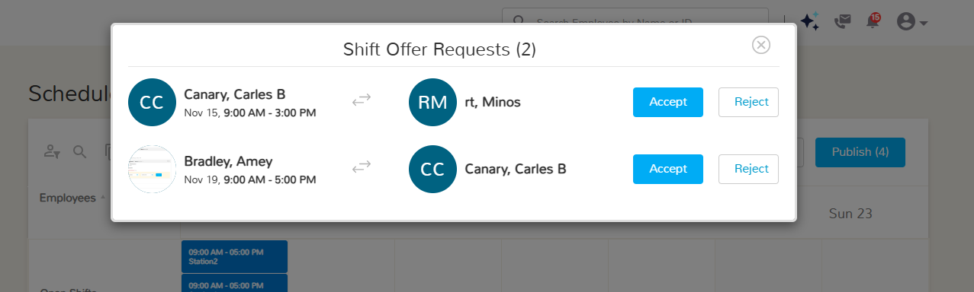

Notification to Employees on Accepting the offer shift request by Admin
Sample Email- Shift offer request approved
DSP has accepted the below shift offer request
Amey's shift details:
Shift Time: 09:00 AM - 05:00 PM
Shift Day and Date: Wednesday, Nov 19, 2025
Requester's Comments:
Original Assignee: Amey Bradley
New Assignee: Carles B Canary
Login to your mobile app to see your updated upcoming shifts or click here to see your updated schedule.
Thank you
Team Uzio
Notification to Employees on Rejecting the offer shift request by Admin
Sample Email
Subject: Shift offer request rejected
James has rejected the below shift offer request
Carles's shift details:
Shift Time: 09:00 AM - 03:00 PM
Shift Day and Date: Saturday, Nov 15, 2025
Requester's Comments:
Original Assignee: Carles B Canary
Intended Assignee: Amey Doe
There is no change in your schedule.
Login to your mobile app to see your upcoming shifts or click here to see your schedule.
Thank you
Team Uzio

Schedule Notifications
UZIO supports a variety of notifications to employees and managers to control and monitor the actual clock in/out time against the assigned shift timings.
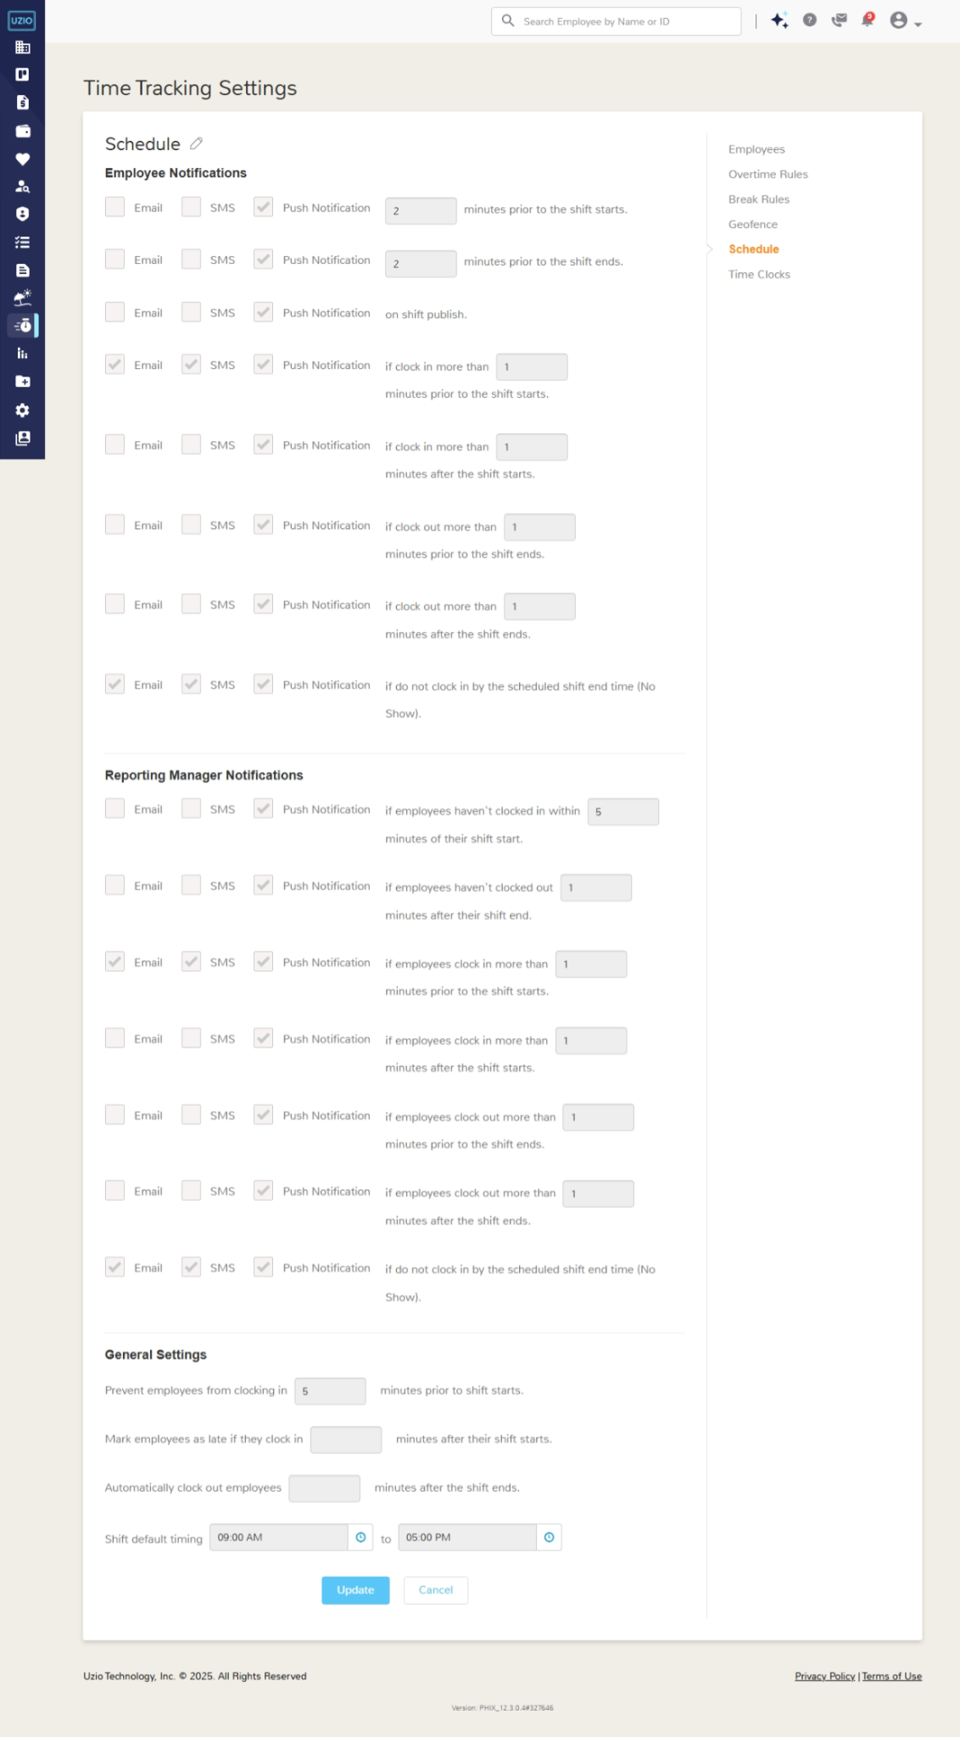

Employee Notifications

Reminder to start shift on time
Email SMS Push Notification ___ minutes prior to the shift starts.
The system reminds employees before the configured time to start the shift on time. Example - If the shift start time is 9AM and the configured time in the setting is 15 Mins then the system will remind the employee at 8:45 AM.

Sample Email
Subject- Reminder: Your shift is about to start at 09:00 AM EST
Body- Hello John,
Your shift for Test Employer starts at 09:00 AM EST. Click here to login.
Thank You
Team UZIO

Sample PUSH Notification
Shift is about to start
Your shift starts at 09:00 AM EST

Sample SMS
Your shift starts at 09:00 AM EST

Reminder to end shift on time
Email SMS Push Notification ___ minutes prior to the shift ends.
The system reminds employees before the configured time to end the shift on time. Example - If the shift end time is 5PM and the configured time in the setting is 15 Mins then the system will remind the employee at 4:45 PM.

Sample Email
Subject- Reminder: Your shift is about to end at 05:00 PM EST
Body- Hello John,
Your shift for Test Employer ends at 09:00 AM EST. Click here to login.
Thank You
Team UZIO

Sample PUSH Notification
Shift is about to end
Your shift ends at 05:00 PM EST

Sample SMS
Your shift ends at 05:00 PM EST

Notification of Shift Publish
Email SMS Push Notification on shift publish.
The system informs employees once their schedule is published.

Sample Email
Subject- Schedule from Mon, 4 Mar 2024 to Wed, 6 Mar 2024
Body- Hello John,
Here are your shifts during the period of Mon, 4 Mar 2024 to Wed, 10 Mar 2024.
Date Shift Start Time Shift End Time
4 Mar, 2024 9:30 AM 05:00 PM
5 Mar, 2024 9:30 AM 05:00 PM
6 Mar, 2024 9:30 AM 05:00 PM
Click here to login and view your schedule.
Thank You
Team UZIO

Sample PUSH Notification
New schedule is published
A new schedule has been published.

Sample SMS
A new schedule has been published.

Alert to employee on early shift start
Email SMS Push Notification if clock in more than ___ minutes prior to the shift starts.
The system sends a notification alert when an employee clocks in earlier than the allowed time before their scheduled shift begins.For example, if the early clock-in threshold is set to 15 minutes and the shift starts at 9:00 AM, the system will automatically send an alert if the employee clocks in before 8:45 AM.

Sample Email
Subject :Alert: You clocked in early.
Body :Hello John,
Your shift is scheduled to start at 09:00 AM but you have clocked in at 08:10 AM. You have clocked in 50 minutes early. Click here to login.

Thank you
Team UZIO

Sample PUSH
You clocked in early
You clocked in 50 minutes early from your scheduled shift

Sample SMS
You clocked in 50 minutes early from your scheduled shift

Alert to employee on late shift start
Email SMS Push Notification if clock in more than ___ minutes after the shift starts.
The system sends a notification alert when an employee clocks in later than the allowed time after their scheduled shift begins.For example, if the late clock-in threshold is set to 15 minutes and the shift starts at 9:00 AM, the system will automatically send an alert if the employee clocks in after 9:15 AM.

Sample Email:
Subject :Alert: You clocked in late.
Body : Hello John,

Your shift is scheduled to start at 09:00 AM but you have clocked in at 09:50 AM. You have clocked in 50 minutes late. Click here to login.

Thank you
Team UZIO

Sample PUSH Notification
You clocked in late
You clocked in 50 minutes late from your scheduled shift

Sample SMS
You clocked in 50 minutes late from your scheduled shift

Alert to employee on early shift end
Email SMS Push Notification if clock out more than __ minutes prior to the shift ends.
The system sends a notification alert when an employee clocks out earlier than the allowed time before their scheduled shift ends.For example, if the early clock-out threshold is set to 15 minutes and the shift ends at 5:00 PM, the system will automatically send an alert if the employee clocks out before 4:45 PM.

Sample Email
Subject :Alert: You clocked out early.
Body :Hello John,
Your shift is scheduled to end at 05:00 PM but you have clocked out at 05:10 PM. You have clocked out 50 minutes early. Click here to login.

Thank you
Team UZIO

Sample PUSH
You clocked out early
You clocked out 50 minutes early from your scheduled shift

Sample SMS
You clocked out 50 minutes early from your scheduled shift

Alert to employee on late shift end
Email SMS Push Notification if clock out more than __ minutes after the shift ends.
The system sends a notification alert when an employee clocks out later than the allowed time after their scheduled shift ends.For example, if the late clock-out threshold is set to 15 minutes and the shift ends at 5:00 PM, the system will automatically send an alert if the employee clocks out after 5:15 PM.

Sample Email:
Subject :Alert: You clocked out late.
Body : Hello John,

Your shift is scheduled to end at 05:00 PM but you have clocked out at 05:50 PM. You have clocked out 50 minutes late. Click here to login.

Thank you
Team UZIO

Sample PUSH Notification
You clocked out late
You clocked out 50 minutes late from your scheduled shift

Sample SMS
You clocked out 50 minutes late from your scheduled shift

Alert to employee on No Show of Shift
Email SMS Push Notification if do not clock in by the scheduled shift end time (No Show).
The system sends an alert notification to employees if they missed to clock in the assigned shift. This notification triggers when the shift end time has been passed and the employee did not clock in to the shift.

Sample Email
Subject :Alert: You missed your shift.
Body : Hello John,

You have not clocked in to your scheduled shift 09:00 AM - 05:00 PM and your attendance has been marked as No Show. Click here to login.

Thank you
Team UZIO

Sample PUSH Notification
You missed your shift
You have not clocked in to your shift 09:00 AM - 05:00 PM

Sample SMS
You have not clocked in to your shift 09:00 AM - 05:00 PM

Manager Notifications

Alert to manager if do not start shift by time
Email SMS Push Notification if employees haven't clocked in within __ minutes of their shift start.
The system sends an alert notification to the manager, if their direct report does not clock in by the configured time from their shift start time. Example- If the threshold is 15 mins and the shift start time is 9AM, the system will send an alert notification to the manager if the direct report employee does not clock in by 9:15 AM.

Sample Email
Subject:Reminder: Few employees are running late and have not started the shift at 09:00 AM
Hello James,

Please see below the list of employees from Test Employer who have not yet clocked in for the shift, scheduled from 09:00 AM to 05:00 PM on Mar 24, 2024

Maria Doe
Wilson Cret

Click here to login and review their schedule.

Thank you,
Team UZIO

Sample PUSH Notification
Few employees are running late
Jack, Daniel, Amanda, Patrick and 5 more are running late for the shift scheduled from 11:00 AM to 07:00 PM EST on Mar 24, 2024

Sample SMS
Jack, Daniel, Amanda, Patrick and 5 more are running late for the shift scheduled from 11:00 AM to 07:00 PM EST on Mar 24, 2024

Alert to manager if do not end shift by time
Email SMS Push Notification if employees haven't clocked out ___ minutes after their shift ends.
The system sends an alert notification to the manager, if their direct report does not clock out by the configured time from their shift end time. Example- If the threshold is 15 mins and the shift end time is 5PM, the system will send an alert notification to the manager if the direct report employee does not clock out by 5:15 PM.

Sample Email
Subject:Reminder: Few employees have not clocked out at 05:00 PM.
Hello James,

Please see below the list of employees from Test Company who have not yet clocked out for the shift, scheduled from 09:00 AM to 05:00 PM on Mar 24, 2024.
Maria Doe
Wilson Cret

Click here to login and review their schedule.

Thank you,
Team UZIO

Sample PUSH Notification
Few employees haven’t clocked out
Jack, Daniel, Amanda, Patrick and 5 more has not clocked out for the shift scheduled from 11:00 AM to 09:00 PM EST on Mar 24, 2024.

Sample SMS
Jack, Daniel, Amanda, Patrick and 5 more are running late for the shift scheduled from 11:00 AM to 07:00 PM EST on Mar 24, 2024

Alert to manager on early shift start
Email SMS Push Notification if employees clock in more than __ minutes prior to the shift starts.
The system sends a notification alert to manager when the direct report employee clocks in earlier than the allowed time before their scheduled shift begins.For example, if the early clock-in threshold is set to 15 minutes and the shift starts at 9:00 AM, the system will automatically send an alert to manager if the employee clocks in before 8:45 AM.
Sample Email
Subject :Alert: John Doe clocked in early.
Hello James,
John Doe has clocked in 30 minutes early at 08:30 AM from the scheduled shift start time 09:00 AM. Click here to login.
Thank you
Team UZIO
Sample PUSH Notifications
John Doe clocked in early.
John Doe has clocked in 30 minutes early from the scheduled shift

Sample SMS
John Doe has clocked in 30 minutes early from the scheduled shift

Alert to manager on late shift start
Email SMS Push Notification if employees clock in more than __ minutes after the shift starts.
The system sends a notification alert to manager when the direct report employee clocks in later than the allowed time after their scheduled shift begins.For example, if the late clock-in threshold is set to 15 minutes and the shift starts at 9:00 AM, the system will automatically send an alert to manager if the employee clocks in after 9:15 AM.

Sample Email
Subject :Alert: John Doe clocked in late.
Hello James,

John Doe has clocked in 30 minutes late at 09:30 AM from the scheduled shift start time 09:00 AM. Click here to login.

Thank you
Team UZIO

Sample PUSH Notification
John Doe clocked in late.
John Doe has clocked in 30 minutes late from the scheduled shift

Sample SMS
John Doe has clocked in 30 minutes late from the scheduled shift

Alert to manager on early shift end
Email SMS Push Notification if employees clock out more than __ minutes prior to the shift ends.
The system sends a notification alert to manager when the direct report employee clocks out earlier than the allowed time before their scheduled shift ends.For example, if the early clock-out threshold is set to 15 minutes and the shift ends at 5:00 PM, the system will automatically send an alert to manager if the employee clocks out before 4:45 PM.

Sample Email
Subject :Alert: John Doe clocked out early.
Hello James,
John Doe has clocked in 30 minutes early at 04:30 PM from the scheduled shift end time 05:00 PM. Click here to login.
Thank you
Team UZIO
Sample PUSH Notifications
John Doe clocked out early.
John Doe has clocked out 30 minutes early from the scheduled shift

Sample SMS
John Doe has clocked out 30 minutes early from the scheduled shift

Alert to manager on late shift endt
Email SMS Push Notification if employees clock out more than ___ minutes after the shift ends.
The system sends a notification alert to manager when the direct report employee out later than the allowed time after their scheduled shift ends.For example, if the late clock-out threshold is set to 15 minutes and the shift ends at 5:00 PM, the system will automatically send an alert to manager if the employee clocks out after 5:15 PM.

Sample Email
Subject :Alert: John Doe clocked out late.
Hello James,

John Doe has clocked out 30 minutes late at 05:30 PM from the scheduled shift start time 05:00 PM. Click here to login.

Thank you
Team UZIO

Sample PUSH Notification
John Doe clocked out late.
John Doe has clocked out 30 minutes late from the scheduled shift

Sample SMS
John Doe has clocked out 30 minutes late from the scheduled shift

Alert to manager on NO Show of Shift
Email SMS Push Notification if do not clock in by the scheduled shift end time (No Show).
The system sends an alert notification to the manager if their direct report missed to clock in the assigned shift. This notification triggers when the shift end time has been passed and the employee did not clock in to the shift.

Sample Email
Subject :Alert: Few employees have missed their shift 09:00 AM - 06:00 PM.

Hello James,

Please see below the list of employees who have missed the shift 09:00 AM - 06:00 PM on Mar 24, 2025.

John Doe
Patric Wilson

Click here to login and review their schedule.

Thank you,
Team UZIO

Sample PUSH Notification
Few employees have missed their shift 09:00 AM - 06:00 PM.
John Doe, Patric Wilson has not clocked in to the shift 09:00 AM - 06:00 PM.

Sample SMS
John Doe, Patric Wilson has not clocked in to the shift 09:00 AM - 06:00 PM.

Schedule Settings
Admin can set the following settings by the following steps
- Login as Employer on the employer portal
- Open Time Tracking Settings from the left navigation
- Go to Schedule form the right
- Locate the respective settings and configure.

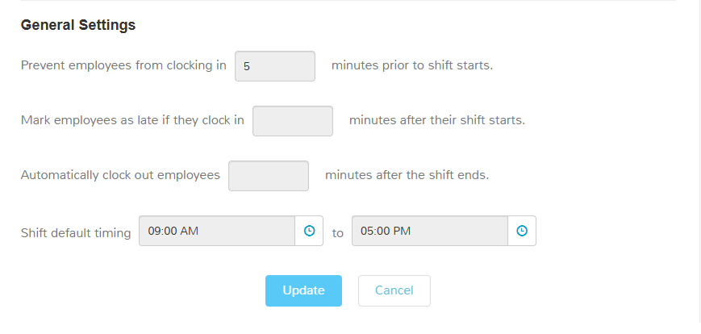

Prevent Early Clock In
To prevent early clock-ins, admins can configure a clock-in restriction setting. When enabled, employees are not allowed to clock in earlier than the defined threshold before their scheduled shift start time.
For example, if the threshold is set to 15 minutes and the shift starts at 9:00 AM, employees will be restricted from clocking in before 8:45 AM for that shift. This ensures that employees begin work within their authorized time window, preventing unnecessary early punches and controlling overtime costs.
However, if an employee chooses to clock in under “Unscheduled”, this restriction does not apply — allowing flexibility for situations where employees are working outside their scheduled shifts.

Mark Late Clock In
To flag a time entry as “Late”, admins can enable the late clock-in setting. When this is configured, the system automatically flags any time entry where an employee clocks in after the defined threshold from their scheduled shift start time.
For example, if the threshold is set to 15 minutes and the shift starts at 9:00 AM, any clock-in after 9:15 AM for that shift will be marked as “Late.” This feature helps maintain punctuality, provides better visibility into attendance patterns, and ensures accurate reporting for performance or compliance tracking.

Default Shift Timings
To define default shift timings, the admin can configure this setting. Once set, these timings automatically prepopulate when creating a new shift, saving time and maintaining consistency across the schedule.
For example, if the default shift time is set as 9:00 AM to 5:00 PM, these hours will appear by default in the shift creation window. However, users can still modify the timings as needed for specific employees or situations before saving the shift.

Employee Experience of Schedule on Web
Employees can view their schedules on the web portal also they can change the view among day/week/month.
To access the schedule:
- Log in to the UZIO employee portal.
- Click on Time Tracking from the top-right menu.
- Go to the “Schedule” tab.
The page displays the employee’s schedule, showing assigned shifts, timings, and related details for the selected period.

Employee Experience of Schedule on Mobile
Employees can view and manage their schedules directly from the UZIO mobile app, with convenient access to shift details and related actions.
To access the schedule:
- Log in to the UZIO mobile app.
- Tap the “Schedule” tab from the bottom navigation bar.
You’ll see the following sections:
- My Shifts – Displays all assigned shifts organized day by day. From here, employees can swap or offer shifts to other eligible coworkers.
- Open Shifts – Shows two options:
  - Available Shifts: View and claim open shifts available at your work location.
  - Requested Shifts: Check the status of your claimed shifts or cancel a claim if needed.
- Shift Requests – Allows employees to manage both swap and offer requests:
  - Swap:
    - Incoming Requests: View requests from coworkers who want to swap shifts with you and accept or reject them.
    - Your Requests: View the swap requests you’ve made and cancel them if required.
  - Offer:
    - Incoming Requests: See offer requests from coworkers who want to give away their shift and accept or reject them.
    - Your Requests: View or cancel the offer requests you’ve initiated.
This mobile interface gives employees full control over their schedules — from viewing shifts to managing swaps, offers, and open shift claims — all in one place.

